UDM ALUMNI MANAGEMENT AND ENGAGEMENT
SYSTEM (AMES): A Data-Driven Approach to
Graduate Employability Tracking

A Capstone Project Presented to the
College of Computing Studies
Universidad de Manila

In Partial Fulfillment of the Requirements for the Degree Bachelor of Science in Information Technology

By
Cabansag, Mikylla Annika A.
Reminal, Grace M.
Zapata, Cedric C.

October 2026

TABLE OF CONTENTS
CHAPTER I 5
INTRODUCTION 5
Project Context 5
Purpose and Description of the Project 7
Objectives of the Project 8
General Objectives 8
Specific Objectives 8
Scope and Limitation 10
Significance of the Study 11
Technical Definition of Terms 12
CHAPTER II 14
REVIEW OF RELATED LITERATURE AND STUDIES 14
Related Literatures 14
Related Studies 18
Synthesis 21
CHAPTER III 23
METHODOLOGY 23
Technical Background of the Study 23
Technologies to be Used 25
Features of the System 26
Conceptual Framework 29
Methodology 31
Type of Research 31
Theoretical and Conceptual Framework of the Methodology 31
Requirement Analysis 34
Functional Requirements 37
Non-Functional Requirements 39
Requirements Documentation 41
Organizational Chart 41
Task Description 42
Operational Feasibility 44
Technical Feasibility 45
Schedule Feasibility 47
Economic Feasibility 49
Design of Software, Systems, Products and Processes 50
Context Flow Diagram 50
Data Flow Diagram 51
Use Case Diagram 53
Activity Diagram 56
System Diagram 60
Development and Testing 62
Front End 62
Back End 64
Unit Testing 65
Test Case 65
Output and User Interface Design 76
Implementation Plan 76
Evaluation Result of the Newly Developed System 76
Evaluation Results 76

CHAPTER I

INTRODUCTION

Project Context
Universidad de Manila (UDM) is a public university committed to providing quality higher education and developing graduates who can contribute to society and the workforce. Monitoring graduates after graduation is an important activity for assessing employment outcomes, understanding the relevance of academic programs to professional careers, and supporting institutional planning and continuous improvement. Through alumni tracer studies, the University can gather information about graduates' educational backgrounds, employment status, career progression, and the relationship between their completed programs and current occupations.
At present, UDM's alumni tracking process relies on an online tracer form and the consolidation of submitted responses in spreadsheets. Although this approach enables the University to collect basic information about its graduates, the process presents challenges in maintaining updated alumni records, consolidating responses, monitoring career outcomes over time, and generating comprehensive employability reports. The absence of an integrated platform for managing alumni information and presenting consolidated statistics may also limit the ability of university administrators and college representatives to readily access relevant information for institutional planning and academic program assessment.
These challenges highlight the need for a centralized and accessible system that can support the systematic collection, management, and analysis of alumni information. A web-based platform can provide a structured process for alumni registration, profile management, tracer survey completion, and employment information updates while making consolidated data available to authorized university personnel. Through appropriate data visualization and reporting functionalities, the University can examine employment outcomes, industry distribution, and the relevance of graduates' occupations to their academic programs.
In response to these needs, the proponents aim to develop the UDM Alumni Management and Engagement System, a web-based platform designed to improve alumni information management and graduate employability monitoring at Universidad de Manila. The system is intended to provide alumni with an accessible means of maintaining their information while enabling authorized administrators and college representatives to manage records, review graduate outcomes, and generate reports for evidence-based decision-making. The project also incorporates access controls and data privacy safeguards to support the responsible handling of alumni information.

Purpose and Description of the Project
The UDM Alumni Management and Engagement System is a web-based information system designed to centralize alumni records and support the collection, management, and analysis of graduate tracer data at Universidad de Manila. It aims to address the limitations of the existing form-based alumni tracking process by providing an integrated platform for alumni information management, career monitoring, and employability reporting.
The system consists of three role-based portals: the Alumni Portal, the College or Department Portal, and the Administrator Portal. The Alumni Portal enables graduates to register, manage their profiles, complete tracer surveys, update employment information, browse job opportunities, and access university events and announcements. These functions allow alumni to maintain their information and participate in the University's alumni engagement activities through a single platform.
The College or Department Portal provides authorized college representatives with access to alumni records and graduate employability information within their assigned college. It includes dashboards, alumni record management, outreach functions, and college-level reports. The Administrator Portal, intended for authorized personnel of the UDM Alumni Relations Office, supports university-wide alumni record management, record verification, job posting administration, event management, analytics, and report generation.
The system consolidates submitted alumni information to produce statistical summaries and visualizations of graduate outcomes, including employment status, employment rates, industry distribution, and the relevance of employment to completed academic programs. Authorized users can access reports according to their assigned permissions, supporting institutional monitoring, academic program assessment, and planning. The system also incorporates authentication, role-based access control, and data privacy safeguards to help ensure that alumni information is accessed and processed only for authorized purposes.
Overall, the project aims to provide Universidad de Manila with a centralized and accessible platform for alumni tracking and career monitoring. Its development is intended to improve the organization of alumni records, facilitate the generation of employability reports, and support data-driven institutional decisions while providing graduates with opportunities to remain connected with the University.

Objectives of the Project

General Objectives
This project generally aims to design, develop, and evaluate the UDM Alumni Management and Engagement System, a web-based platform that centralizes alumni information, facilitates the collection and updating of graduate tracer data, and provides employment analytics and reports to support evidence-based decision-making, graduate employability monitoring, and institutional planning at Universidad de Manila.

Specific Objectives
- Assessed the current alumni tracking practices of Universidad de Manila, specifically evaluating the operational limitations and data consolidation gaps of the existing manual, Google Form-based process.
- Designed a centralized database capable of securely storing and managing alumni profiles, educational backgrounds, employment information, and tracer survey responses.
- Develop an online alumni registration, profile management, and tracer survey module that enables graduates to submit, update, and maintain their personal, educational, and employment information.
- Developed role-based administrative and college dashboards that displayed real-time employability analytics (employment rate, course-job alignment, time-to-first-job, industry distribution) and generated exportable institutional compliance reports in PDF, Excel, and CSV formats.
- Implemented user authentication and data privacy safeguards consistent with the Data Privacy Act of 2012 (RA 10173), including role-based access control (RBAC), explicit consent, and audit logging to protect alumni personal information.
- To evaluate the UDM Alumni Tracer and Career Monitoring System in accordance with ISO 25010's criteria in terms of the following:
  - Functionality
  - Reliability
  - Efficiency
  - Usability
  - Security
  - Portability

Scope and Limitation
The study focused on the design, development, and evaluation of a responsive, web-based alumni tracking and career monitoring platform, officially designated as the UDM Alumni Tracer and Career Monitoring System (UDM-AMES), for Universidad de Manila (UDM). The system encompassed graduates from batches 1999 onward across all academic colleges and degree programs. Technically, the platform was developed as a single-page web application utilizing React for front-end rendering, a Laravel REST API for server-side business logic, and PostgreSQL for relational data storage. System access and feature rights were managed strictly through Role-Based Access Control (RBAC) distributed across three primary user roles: Alumni, College/Department Coordinators, and System Administrators.
The scope of the Alumni Module enabled graduates to complete self-registration using their official Alumni Membership IDs, integrated mandatory consent handling in compliance with the Data Privacy Act of 2012 (RA 10173), and provided automated email verification, password resets, and forced first-time password updates. At the core of the portal was an 8-section skip-logic tracer survey engine that recorded personal details, educational background, employment status, career history, self-employment data, and institutional feedback while supporting real-time completion indicators and save-and-resume functionality. Furthermore, graduates were provided with an interactive job board featuring external contact hand-offs, event registration with calendar synchronization, and a self-service data privacy panel allowing profile visibility toggles, proof of employment document uploads via private signed links, and personal data exports in JSON format.
The College Module catered to College Deans and Program Chairs by providing department-restricted dashboards that displayed real-time key performance indicators, including employment rates, time-to-first-job, course-to-job relevance, and employment status mix per degree program. To assist in graduate support, the module incorporated a targeted outreach queue that identified untraced or unemployed alumni, allowing college personnel to initiate direct follow-ups via native email or Facebook Messenger while logging contact histories. College heads were also empowered to generate and export program-specific graduate outcome reports locked strictly to their assigned academic departments.
The Admin Module, managed by the Alumni Relations Office, featured an automated data management engine capable of ingesting registrar graduate masterlists in CSV and Excel formats up to 2,000 rows. This engine executed server-side validation, cleaned data, resolved record conflicts, dispatched temporary login credentials, and maintained audit logs with batch rollback capabilities. Administrators were also equipped with a 9-section dynamic tracer question manager to customize survey fields without corrupting core reporting statistics, alongside moderation queues for job postings, event management, and system announcements. Additionally, the admin interface automated the generation of five official institutional compliance report types including the UDM Alumni Survey Form A, Employability by Program, Batch Coverage Audit, Employer Distribution, and Inclusion Profiles, exportable in PDF, Excel, and CSV formats.
Regarding the delimitations of the study, the platform was developed exclusively as a responsive web application optimized for desktop, tablet, and mobile web browsers, explicitly excluding native mobile application development for iOS or Android. In terms of communication, direct messaging was restricted to one-to-one threads between system roles without peer-to-peer alumni social networking, public feeds, or automated bulk SMS and email marketing campaigns; messaging hand-offs redirected users to external native mail apps or Facebook Messenger. Furthermore, employment metrics and salary details relied entirely on self-reported survey entries and registrar masterlists without automated third-party background verification through external employers or government agencies such as SSS, GSIS, or BIR.
The study was delimited by system architecture and administrative boundaries. The platform operated as an independent web application without direct, real-time API integration into the university's Student Information System, relying instead on file-based registrar imports. Financial and administrative workflows such as online payment processing, donation collecting, alumni fee gathering, physical card printing, transcript handling, and document clearance were strictly excluded from the system's scope. Additionally, third-party employers were not granted direct portal accounts, and job postings were moderated solely by administrators without Applicant Tracking System features like resume parsing or automated candidate scoring. The entire user interface and output compliance reports were developed exclusively in the English language.

Significance of the Study
The development of the UDM Alumni Tracer and Career Monitoring System is expected to benefit the following stakeholders:
University Administration and Office of the President. The system benefits the university administration by establishing centralized alumni records and employment reports that automates graduate tracking and generates ready reports for CHED and institutional evaluation. It supports institutional planning and decision-making by making graduate employment outcomes more accessible and simplifying the preparation of reports for institutional monitoring and evaluation.
College Deans and Program Coordinators. The system provides college-level dashboards displaying employability rates, degree-to-job alignment, and time-to-first-job per program. These empirical metrics enable deans and department heads to conduct periodic curriculum reviews and better align academic offerings with industry demands.
Alumni Relations Office (ARO). The system provides the administrative office with centralized alumni management tools to simplify account verification using official Alumni IDs, manage tracer survey content, and automate institutional data processing. It reduces the manual operational workload of staff while ensuring data integrity and compliance for university-wide reporting.
UDM Merlion Alumni Association (UDM-MAA). The system strengthens the Association's capability to reconnect with graduates and maintain updated alumni directories. Built-in job board moderation, event registration features, and official announcements empower the organization to foster active networking, mentorship programs, homecoming events, and community initiatives.
Career Development and Guidance Offices. Employment trend data will help these offices design more targeted career guidance, job fairs, and industry-linkage programs for graduating students.
Current Students and Future Graduates. Insights on the career paths of alumni can help current students make informed decisions about their courses and future careers, while showcasing the achievements of UDM graduates.
UDM Alumni. A centralized platform gives graduates an easier, faster way to stay connected with the University and with fellow alumni, and to be informed of relevant opportunities and initiatives.
Future Researchers and Developers. This study serves as a reference for future research on tracer studies, graduate employability analytics, and the development of similar data-driven information systems in other higher education institutions.

Technical Definition of Terms
Administrator / Admin Module. The central component of the system reserved for authorized Alumni Relations Office personnel to validate graduate accounts, manage tracer survey content, moderate job postings, and generate university-wide compliance reports.
Alumni Relations Office (ARO). The official administrative unit of Universidad de Manila responsible for institutional alumni tracking, records verification, data privacy compliance, and official reporting to CHED and university leadership.
Alumni Tracer Study. A survey-based research methodology used by higher education institutions to systematically gather data on the employment status, career progression, and retrospective curriculum feedback of its graduates.
Career Monitoring. The continuous, longitudinal process of tracking and recording an alumnus’s professional milestones and career updates over time beyond a one-time tracer survey.
Dashboard. A visual analytical interface within the system that displays aggregated summaries, charts, and key performance indicators (KPIs) such as employment rate, time-to-first-job, and program-job alignment.
Data Privacy Act of 2012 (RA 10173). A Philippine law that protects individual personal data in information and communications systems, governing how the platform collects, processes, stores, and exports alumni records[4][6].
Database. An organized, relational data store (PostgreSQL) that securely holds user credentials, alumni profiles, academic records, survey responses, and job postings.
Data-Driven Approach. A decision-making methodology that relies on the systematic collection, processing, and empirical analysis of factual graduate data rather than intuition or manual observation.
Employability. The capacity and rate at which graduates secure and maintain meaningful employment relevant to their completed academic degree program.
Graduate. An individual who has officially completed and been conferred an academic degree or program by Universidad de Manila.
Respondent. A verified graduate of UDM who accesses the online portal to complete or update their alumni tracer survey.
Role-Based Access Control (RBAC). A system security mechanism that restricts feature access and permissions strictly according to a user’s assigned role (Alumni, College Coordinator, or Admin).
Skip-Logic Survey. A survey mechanism that dynamically adapts question pathways based on a respondent's previous answers (e.g., automatically bypassing detailed employment questions for unemployed respondents).
UDM Merlion Alumni Association (UDM-MAA). The official organization of UDM graduates focused on alumni community building, directory maintenance, networking, mentorship, homecoming events, and graduate outreach.
Web-Based System. An application accessed through a standard desktop or mobile web browser over the internet, eliminating the need for client-side software installation.

CHAPTER II

REVIEW OF RELATED LITERATURE AND STUDIES
This chapter compiles the literature, studies, and systems relevant to the researchers' study.

Related Literatures
Digital transformation in higher education institutions has become a well-established research area supported by systematic literature reviews published within the last five years. Mabotha and Ngcamu (2026) conducted a systematic review of eighty studies published between 2019 and 2025 on digital transformation in the higher education sector and found that universities have been exploiting digital tools to improve performance, restructure business processes, and modernize administrative systems and practices. Their review, anchored on connectivism theory, identified digital skills, benefits, barriers, and challenges as the four dominant themes in the literature, with barriers such as inadequate funding, employee resistance, limited digital literacy, and insufficient infrastructure most frequently reported as obstacles to the full realization of digital transformation's benefits. The same review noted a pronounced imbalance in the literature, with the majority of published studies originating from Global North contexts such as the United States, United Kingdom, and Germany, while only a smaller share came from Global South contexts such as South Africa, India, Brazil, and Nigeria, a gap that Philippine capstone and thesis research, including the present study, helps to address.
Literature on web based scheduling and self service systems, though largely drawn from the healthcare sector, offers transferable insight applicable to any web based, self service platform in an institutional setting. Woodcock (2022) conducted a scoping review of automated patient self scheduling systems and found that such systems reduce administrative workload and give users greater control over when they complete a transaction, while identifying limited system integration, unclear organizational ownership, and inconsistent user adoption as recurring barriers to successful implementation. These findings support the design rationale behind self service, browser accessible platforms such as the UDM Alumni Tracer and Career Monitoring System, where alumni are expected to complete their tracer profile independently rather than through an in-person or paper-based transaction.
Literature on electronic governance, or e-governance, in higher education frames campus information systems within a broader public administration context. E-governance is described as the use of information and communication technologies for the planning, implementation, and monitoring of government and institutional programs, intended to reduce reliance on manpower, improve administrative efficiency, and increase transparency and the speed of information dissemination. Applied to universities, e-governance literature identifies registration, admission, student information, attendance, examinations, and reporting as the core administrative processes that benefit most from ICT-enabled governance, situating an alumni information system as one component of a university's broader digital governance apparatus rather than a standalone tool.
In the Philippine setting, the modernization of registrar and student affairs functions is closely tied to institutional accreditation and data privacy compliance. Philippine higher education institutions, including the University of Santo Tomas, the University of Batangas, the University of the East, and the Technological University of the Philippines, have progressively shifted core registrar functions online, offering services such as verification of student records, online application for transcripts of records and other credentials, and status tracking of walk in or online requests, reflecting a shared institutional recognition that registrar services once handled exclusively through in person, paper based transactions are increasingly expected to be available online. The University of Batangas Registrar's Office, for example, explicitly frames its vision as becoming fully automated through an integrated, web based enrollment and records system that provides systematic and convenient processing of student records.
Local literature on software quality evaluation has also shaped how Philippine capstone and thesis researchers assess newly developed academic information systems. The ISO/IEC 25010 quality model, covering functional suitability, performance efficiency, compatibility, usability, reliability, security, maintainability, and portability, has become the standard evaluation framework adopted across Philippine registrar and student services system studies, providing a validated, internationally recognized basis for measuring end user satisfaction through a Likert type questionnaire.
Republic Act No. 10173, or the Data Privacy Act of 2012, further shapes local literature on academic records systems by requiring that any information system handling personal data implement organizational, physical, and technical safeguards proportionate to the sensitivity of the data being processed, and by granting data subjects, such as students and alumni, the rights of access, correction, and erasure over their personal information. Because systems such as the UDM Alumni Tracer and Career Monitoring System are designed to store demographic, educational, and employment data voluntarily submitted by alumni, this body of literature directly informs the authentication, access control, and data protection features built into the system.

Related Studies
Several empirical studies conducted outside the Philippines demonstrate the practical benefits and constraints of automating administrative and governance processes in higher education. Parnashree and Rakshith (2023) examined the adoption of e governance systems among higher education institutions in the Mysore region of India and found that information and communication technology enabled governance reduced administrative manpower requirements while improving the efficiency of managing core academic activities such as registration, admission, student information, attendance, and examinations, and improved transparency and the speed of institutional reporting. Their study, based on primary and secondary data collected from lecturers and administrative staff in colleges around Mysore, also cautioned that the full benefits of e governance depend on institutions overcoming both technical barriers, such as unstable infrastructure, and non technical barriers, such as insufficient staff training.
Kayanja, Kyambade, and Kiggundu (2025) conducted a qualitative study at Makerere University Business School in Uganda examining the shift toward fully automated and paperless institutional systems. They found that automation reduced administrative burdens for staff while giving students more flexible and improved access to services, with cloud computing enabling institutions to manage large volumes of student data efficiently and to support remote or hybrid service delivery. Citing the successful transition of Makerere University's e learning and administrative services platform and the University of Cape Town's digital student management systems as examples, the study concluded that institutional leadership, government support, and international partnerships are central to overcoming the infrastructure deficits and resource constraints that continue to affect institutions in developing regions, a challenge with direct relevance to Philippine state and local universities such as Universidad de Manila.
Philippine higher education institutions have produced a growing body of empirical, system development research directly relevant to the UDM Alumni Tracer and Career Monitoring System. Ampuan and Delena (2022) implemented and evaluated a web based appointment system for the Office of the President at Mindanao State University, Main Campus, reporting an overall user satisfaction rating of 90.2 percent using the System Usability Scale and Technology Acceptance Model, and concluding that the system improved client waiting time and allowed both students and employees to schedule appointments more conveniently than the manual process it replaced.
At Cavite State University, Main Campus, Peji, Bondoc, and Rabosa (2024) developed an online counseling appointment system for the Guidance Office under the Office of Student Affairs and Services, incorporating registration, login, self assessment, informational content, SMS notification, scheduling, and reporting features intended to help the counseling unit monitor and improve the quality of mental health services provided to students. This study illustrates how appointment and case tracking features validated in administrative offices can be extended into student welfare services within the same institution.
Adra, Sarmiento, and Bausa (2024) developed a Student Services Digital Records Management System for the Registrar's Office of a private Philippine college, designed to maintain detailed digital records of student credentials such as transcripts of records, diplomas, good moral certificates, and honorable dismissals, with a report generation module for viewing and printing requested documents and an email based notification feature for account verification. The system was developed using the Agile methodology and evaluated against the ISO/IEC 25010:2011 standard by ten information technology experts, three school administrators, and ten students, obtaining an overall weighted mean rating of 4.0, interpreted as far exceeding expectations across all eight quality characteristics evaluated, including usability, security, and maintainability.
Casicas, Castro, Macaindig, and Labadan (2024) developed the ODR.REGISTRAR-COC.EDU.PH Online Document Requisition System, a web based platform that allows PHINMA Cagayan de Oro College students and alumni to request academic documents online and to track the status of their request as it moves through a multi step approval process involving the dean, librarian, finance office, student affairs office, and registrar. The system was likewise built using the Agile methodology, and usability testing yielded a mean score of 79.4, indicating that respondents found the system understandable, functional, and effective in addressing the inefficiencies of the manual, in person document requisition procedure it replaced.

Synthesis
Taken together, the reviewed foreign and local literature and studies converge on several conclusions directly relevant to the development of the UDM Alumni Tracer and Career Monitoring System. First, both foreign and local literature confirm that web based, self service platforms consistently outperform manual or in person processes in terms of user satisfaction, waiting time, and administrative efficiency, supporting the design decision to make alumni registration and survey completion fully self service. Second, local empirical studies, namely the Mindanao State University appointment system, the Cavite State University counseling system, the Student Services Digital Records Management System, and the ODR Online Document Requisition System, demonstrate that Philippine higher education institutions have already validated the core technical components proposed for the UDM system, namely online registration, status tracking, role based administrative workflows, and automated notifications, at other Philippine colleges and universities, lending strong local precedent to the proposed system's feature set.
Third, the ISO/IEC 25010 quality model recurs across both foreign conceptual literature and local empirical studies as the preferred instrument for evaluating newly developed academic information systems, reinforcing its adoption as the evaluation framework used in Chapter III of this study. Fourth, the foreign literature on digital transformation and e-governance cautions that the benefits of automation are not guaranteed by technology alone; they depend on institutions addressing funding, infrastructure, staff digital literacy, and change management alongside system development, a consideration that supports including user training and change management steps in the data gathering and deployment procedure of this study.
Finally, a persistent gap across both foreign and local studies is that most reviewed systems automate a single administrative transaction, such as a document request or an appointment booking, without connecting that data to longitudinal, institution wide analytics. The UDM Alumni Tracer and Career Monitoring System addresses this gap directly by pairing its registration and survey modules with an employability analytics dashboard.

CHAPTER III

METHODOLOGY
This chapter presents the methodology followed by the researchers in the design and development of the UDM Alumni Tracer and Career Monitoring System: A Data-Driven Approach to Graduate Employability Tracking. It discusses the technical background of the study, the technologies used, the features of the system, the conceptual framework, the research methodology and software development life cycle applied, the requirement analysis, the requirements documentation, the design of the software, and the development, testing, and implementation plan carried out by the researchers.

Technical Background of the Study
The University's present alumni monitoring practice relied on a single Google Form, distributed through printed posters, QR codes, and a Facebook alumni group, which collected responses stored as raw spreadsheet rows in Google Sheets. While this required no infrastructure investment and was easy to deploy, it had clear technical limitations — no relational data model linking a respondent's personal record to their multiple employment histories over time, only the branching logic native to Google Forms rather than a fully validated survey flow, no role-based access control, and no built-in analytics layer, meaning every statistic reported to the administration, the colleges, or accrediting bodies had to be computed manually. At the time of the study, the form had already gathered over a thousand alumni responses, yet these remained unprocessed, unnormalized data rather than actionable institutional intelligence.
The UDM Alumni Tracer and Career Monitoring System was proposed as a browser-based, layered application to directly address these gaps, organized into three technical layers: a presentation layer composed of an alumni-facing portal and separate college and administrator dashboards; an application layer housing the membership and authentication service, the multi-section tracer survey engine, the employability analytics and AI-assisted insights module, the report generator, and a job opportunities board; and a data layer built on a relational database that stored alumni profiles, academic records, survey responses, job postings, and membership credentials as related entities rather than flat spreadsheet rows. This structure allowed survey skip logic to be enforced consistently at the application level and allowed employability statistics — employment rate, course-job alignment percentage, time-to-employment — to be computed automatically from stored records rather than tallied by hand. Access was gated by the alumni's Membership ID, consistent with the Alumni Office's existing membership process, with role-based permissions distinguishing alumni respondents, college-level coordinators, and Alumni Office administrators. Because the system handled personal data such as contact information, addresses, and employment details, it incorporated safeguards consistent with the Data Privacy Act of 2012 (RA 10173), including access controls, encrypted storage of sensitive fields, and restricted export of raw personal data outside the reporting module.
On the data and development side, the system was initially populated with dummy data to test its survey logic, analytics computations, and dashboard outputs, consistent with the Alumni Office's preference to validate functionality before live deployment. The University's existing pool of over a thousand Google Form responses was identified as a candidate for subsequent cleaning and migration into the new relational database as historical records, reducing the need for previously surveyed alumni to answer again. The system was implemented as a standard multi-tier web application, accessible through common browsers and responsive to mobile devices, using React.js and Node.js for the front end and application logic, MariaDB as the relational database management system, and Amazon Web Services (AWS) as the cloud hosting environment.

Technologies to be Used
The researchers utilized a variety of web technologies to develop the system and manage database connections.
For the frontend or user interface, HTML (Hypertext Markup Language) and CSS (Cascading Style Sheets) were used to structure and style the web pages, while React.js was employed to create dynamic and responsive components for the alumni registration, tracer survey, and administrative dashboard modules. JavaScript was integrated to provide interactivity within the user interface, including real-time form validation and dynamic chart rendering.
On the server side, Node.js was utilized to handle application logic and server-side processes, including account authentication, survey response processing, and report generation. To manage and manipulate the database, MariaDB was utilized as the relational database management system, ensuring efficient storage, organization, and retrieval of alumni demographic, educational, and employment records while supporting data protection requirements under Republic Act No. 10173, or the Data Privacy Act of 2012.
Various types of data analytics were employed, with a particular emphasis on descriptive analytics. This was demonstrated through insights presented in the form of graphs, such as bar charts, pie charts, and line graphs, summarizing alumni employment rates, job relevance to degree programs, industry distribution, and income brackets. Additionally, predictive analytics was utilized to highlight projected employability trends of graduates across academic programs, providing University administrators with insights that may support curriculum evaluation and institutional decision-making.

Features of the System
This study provides different features of the UDM Alumni Tracer and Career Monitoring System. The function of this system is to improve the University's alumni tracking and employability monitoring process by replacing the existing manual, form-based approach with a centralized, data-driven platform that automates data collection, applies skip-logic surveys, and generates descriptive analytics and AI-assisted insights to support institutional decision-making.
The following are the functions of the project:
- Alumni Portal – allows alumni to register using their Alumni Membership ID, log in, and maintain their personal profile (name, address, email, Facebook Messenger, batch/program, affiliations).
- Tracer Survey Module – an eight-section, skip-logic survey covering personal information, educational background, and employment or self-employment details, automatically directing respondents away from irrelevant questions based on their employment status.
- Career/Employment Update – lets alumni revisit and update their employment information over time, supporting longitudinal tracking rather than a single one-time survey.
- Job Opportunities Board – a module where the Alumni Office (and, pending confirmation, partner employers) can post job openings for alumni to browse.
- College Dashboard – gives each of the seven colleges a filtered view of employability analytics limited to their own programs.
- Admin Dashboard – gives the Alumni Office full administrative control: membership validation, survey content management, and university-wide reporting.
- Analytics & AI-Assisted Insights Module – computes employability indicators (employment rate, course alignment, time-to-employment, industry distribution) and highlights notable trends.
- Alumni Database – the central relational data store holding profiles, survey responses, job postings, and membership records.

Conceptual Framework
INPUT
PROCESS
OUTPUT
Knowledge Requirements

- Review of Related Literature, Studies and Systems
- Observation
- Interview

Requirement Analysis
- Software Requirements
HTML
CSS
JavaScript
React.js
Next.js
Node.js
MariaDB

Hardware Requirements
Windows 10/11, 8GB RAM
Stable Internet Connection

Software Development Lifecycle (SDLC) Model
Agile/Scrum Model

Phases
- Product backlog creation (from requirements gathering with the Alumni Office)
- Sprint planning
- Sprint development, and review (iterative cycles)
- Sprint retrospective and backlog refinement

- UDM Alumni Tracer and Career Monitoring System: A Data-Driven Approach to Graduate Employability Tracking

- User's Manual

Evaluation / Feedback

Figure 1. Input-Process-Output Model of the UDM Alumni Tracer
and Career Monitoring System
The conceptual framework depicted the overall phases of the study, including the input, process, output, and evaluation/feedback phases.
In the input phase, various techniques were employed, including identifying knowledge requirements, gathering requirements, and analyzing them. In the knowledge requirement phase, existing research studies, related literature, and existing systems relevant to alumni tracking and career monitoring were reviewed. For the requirement gathering phase, observations and interviews with relevant personnel from the Alumni Office were conducted to identify the current practices, needs, and challenges in monitoring alumni information. In the requirement analysis phase, the gathered information was examined and organized to identify the software and hardware requirements necessary for the development and operation of the proposed system.
In the process phase, different Software Development Life Cycle (SDLC) models were considered, and the Agile/Scrum Model was chosen, as discussed further under the Methodology section of this chapter.
In the output phase, the study resulted in the development of the proposed system entitled “UDM Alumni Management and Engagement System: A Data-Driven Approach to Graduate Employability Tracking,” together with its User's Manual intended to guide alumni, college coordinators, and authorized Alumni Office administrators in using the system. The framework also included an evaluation/feedback phase, wherein the developed system was evaluated based on the identified software quality criteria, with the results feeding back into succeeding development cycles.

Methodology

Type of Research
This study employed developmental research, a type of research concerned with the design, development, and evaluation of a product — in this case, the UDM Alumni Management and Engagement System — rather than the testing of a hypothesis about an existing phenomenon. Unlike traditional research designs that set out to explain a problem and arrive at a solution through experimentation, developmental research produced a working system as its principal output, with feasibility, functionality, and user acceptance serving as the primary measures of success. The study also carried a quantitative dimension, as the evaluation of the developed system relied on numerical ratings gathered through a Likert-type questionnaire administered to respondents, which were statistically summarized to assess the system's compliance with the ISO/IEC 25010 quality characteristics identified in Chapter I.

Theoretical and Conceptual Framework of the Methodology
The researchers adopted the Agile/Scrum framework as the software development life cycle (SDLC) for the study. Agile/Scrum was selected, among other models considered such as the Spiral Model and Rapid Application Development (RAD), because the iterative, sprint-based structure of Scrum accommodated the evolving requirements of the Alumni Office throughout the requirements-gathering and development period, allowed the researchers to demonstrate working increments of the system to stakeholders at the end of each sprint, and made it possible to incorporate feedback progressively rather than only at the end of development. This section discusses how the Agile/Scrum framework was applied to the study rather than defining the model itself, as the model is already defined under the Technical Definition of Terms in Chapter I.
In applying the framework, the Alumni Office, represented by the Head of Alumni, served as the Product Owner, responsible for defining and prioritizing the system requirements, while the student researchers served as the Development Team responsible for designing, developing, testing, and delivering each system increment. The Product Backlog contained the prioritized list of system features identified during the requirements analysis, including the membership and authentication module, the tracer survey engine, the job opportunities board, the analytics and AI-assisted insights module, and the report generator.
During Sprint Planning, the researchers selected and organized backlog items into manageable tasks for the current sprint. Throughout each sprint, Daily Scrum meetings were conducted to monitor progress, identify challenges, and address development blockers. At the end of each sprint, a Sprint Review was conducted to demonstrate the completed Product Increment to the Alumni Office and other stakeholders and to gather feedback for further improvement. A Sprint Retrospective then allowed the development team to evaluate the completed sprint, identify areas for improvement, and apply the lessons learned to the succeeding cycle. Feedback and recommendations from the stakeholders were incorporated into the Product Backlog, allowing the system requirements and priorities to be continuously refined throughout development.
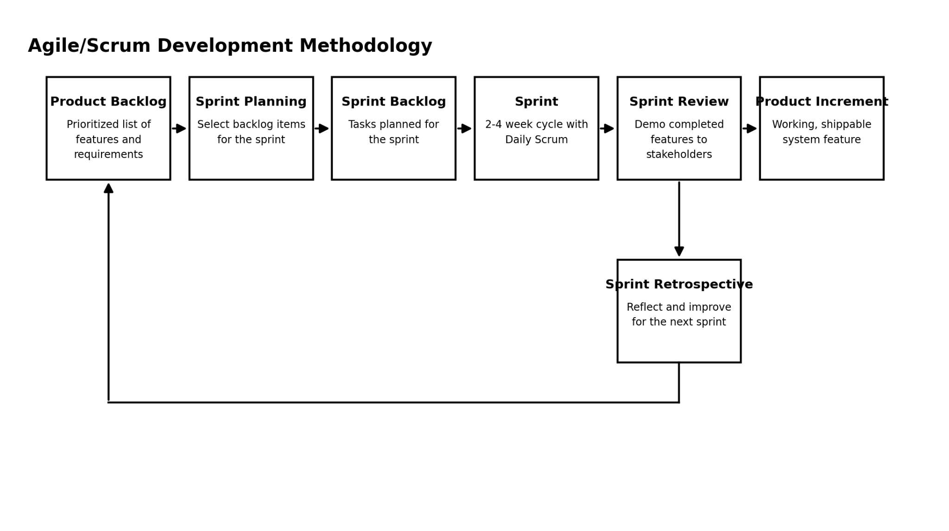
Figure 2. Agile/Scrum Software Development Life Cycle
The Agile/Scrum framework was found suitable for the development timeframe and requirements of the UDM Alumni Tracer and Career Monitoring System because it promoted continuous development, frequent testing, and active stakeholder involvement throughout the project. Unlike development approaches that required requirements to be finalized at the outset, Agile/Scrum allowed changes and additional requirements to be accommodated during development — a benefit that proved relevant to features such as the Job Opportunities Board, which was refined based on the needs and feedback of the Alumni Office as the project progressed. The framework also enabled the researchers to prioritize essential modules, such as alumni membership, authentication, and the tracer survey, and to develop these earlier before proceeding to other system features, with each functional increment reviewed and validated by stakeholders before additional features were built. This continuous feedback cycle allowed the researchers to respond to changing requirements, identify issues at an early stage, and progressively improve the system until all planned features were completed, integrated, and evaluated.

Requirement Analysis
In designing and developing the UDM Alumni Management and Engagement System: A Data-Driven Approach to Graduate Employability Tracking for Universidad de Manila, the researchers started the process with a requirement analysis. This phase began with a brainstorming session among the researchers, to which they identified issues that required research and the development of a new system. The data collection started with secondhand observations at Universidad de Manila, where the researchers drew from the University's official website and social media channels, noting how the existing "UDM Merlion Alumni Tracer" Google Form was distributed through posters, QR codes, and a Facebook alumni group. The insights gained from these observations were then compiled for further analysis. The researchers thoroughly considered all the issues associated with the University's current manual, form-based alumni tracking process. To better understand these challenges, they engaged in a detailed interview with Mr. Iserlohn Peter Lim, Head of the UDM Alumni Association, who served as the Product Owner and primary resource person for the study.
The interview confirmed that as of July 31, 2026, the existing Google Form had already collected 1,405 responses, yet these remained unprocessed spreadsheet entries rather than analyzed institutional data, reinforcing the need for a centralized system with built-in analytics. Several key requirements and constraints were clarified during this engagement. First, on the matter of job posting rights for the Job Opportunities Board, it was confirmed that a third user type, an Employer Account, would be needed in addition to the Alumni and Admin accounts, to allow employers to post job openings directly. Second, on the question of batch coverage, it was resolved that the system's initial tracer coverage would be limited to the five most recent graduating batches. Third, regarding system ownership, it was clarified that the Alumni Office itself would serve as the system administrator, since it is the office responsible for cascading information down to the colleges ("sila magsscale sa colleges"). This arrangement was reinforced by the absence of a currently active Alumni Association to share administrative responsibility with, meaning the Alumni Office remains the sole owner and administrator of the system, while the colleges are limited to filtered, view-only dashboard access rather than edit rights.
Fourth, on the matter of data population, it was confirmed that the system would follow a dummy-data-first approach for initial testing, with the exact start date for real data collection still to be determined. Fifth, and most significantly for the design of the survey module, the interview surfaced the reasons behind incomplete or abandoned tracer form submissions: alumni reported that the current Google Form contained too many questions, resulting in survey fatigue that respondents described as tedious ("nahihirapan") and that made them reluctant ("tinatamad") to finish. This finding directly supports the system's planned multi-step, save-and-resume, skip-logic survey design. Related to this, the interview also revealed persistent issues surrounding alumni membership registration, including alumni taking no definite action on registration because of the associated membership payment, alumni who remain unauthorized or unverified members, and alumni who are simply hesitant to register, all of which are compounded by the lack of an active Alumni Association to assist in member verification and outreach. In addition to these discussions, the researchers examined various online resources, seeking studies and reports from other institutions that have encountered similar difficulties in alumni tracking and tracer study administration. This extensive literature review helped them uncover best practices and strategies that could be relevant to their own situation.

Functional Requirements
The functional requirements describe the specific functions and services that the system shall provide to its intended users. These requirements are categorized according to the different modules and user roles of the proposed system.
Alumni Portal
The Alumni Portal shall provide alumni with the necessary functions to register, access, and maintain their information within the system. The system shall:
- Allow alumni to register an account using their Alumni Membership ID.
- Allow registered alumni to log in and manage their personal profile, including their name, address, email, Facebook Messenger, batch or program, and affiliations.
- Present a multi-section tracer survey covering personal information, educational background, and employment or self-employment details. The system shall apply skip logic to display only the sections relevant to the alumnus's employment status.
- Allow alumni to update their employment and career information after completing their initial survey submission to support longitudinal career tracking.
- Allow alumni to browse available job postings through the Job Opportunities Board.
College Dashboard
The College Dashboard shall provide college coordinators with access to employability information relevant to their assigned college and programs. The system shall:
- Display employability analytics, including employment rate, course-job alignment, and industry distribution, filtered according to the coordinator's assigned college and program.
Admin Dashboard
The Admin Dashboard shall provide authorized Alumni Office administrators with functions for managing alumni records, survey content, job opportunities, and institutional reports. The system shall:
- Allow administrators to validate and manage alumni membership records.
- Allow administrators to create, edit, and manage tracer survey content.
- Allow administrators to post, edit, and remove job opportunity listings.
- Generate university-wide employability reports formatted to support compliance requirements.
Analytics and Reporting
The Analytics and Reporting component shall process collected alumni information and transform it into useful employability data for institutional decision-making. The system shall:
- Automatically compute descriptive employability statistics, including employment rate, time-to-employment, and course alignment percentage, using the stored survey data.
- Provide AI-assisted insights that identify and highlight notable employability trends across colleges and academic programs.

Non-Functional Requirements
The non-functional requirements define the quality attributes and operational characteristics that the system must satisfy. These requirements are aligned with the ISO/IEC 25010 criteria identified in the objectives of the study and are intended to ensure that the developed system is functional, efficient, secure, reliable, and maintainable.
- Functional Suitability – The system shall correctly perform all specified functions, including survey skip logic, data validation, information processing, analytics computation, and report generation. The system shall produce accurate, complete, and appropriate results based on the data provided.
- Performance Efficiency – The system shall provide acceptable response times when loading dashboards, processing survey data, and generating analytics. The system shall also remain capable of handling an increasing volume of alumni records, considering that the University's existing tracer form has already collected more than a thousand responses.
- Compatibility – The system shall function properly across commonly used web browsers and shall be designed to operate without conflicts with existing systems and tools used by the Alumni Office and the University's colleges.
- Usability – The system shall provide an intuitive and mobile-responsive user interface that allows alumni and administrators to perform their respective tasks with minimal difficulty. The tracer survey shall use a multi-step and save-and-resume approach to reduce survey fatigue and accommodate alumni who access the system primarily through mobile devices.
- Reliability – The system shall maintain consistent operation and recover appropriately from system failures. It shall also ensure that successfully submitted alumni survey responses and other important records are not lost during system interruptions or unexpected errors.
- Security – The system shall implement role-based access control to restrict system functions and information according to user roles. Personal information shall be protected in accordance with the Data Privacy Act of 2012 (RA 10173), including the use of encrypted storage for sensitive fields and restrictions on the export and access of raw personal data.
- Maintainability – The system shall follow a modular design that separates major components, including membership and authentication, tracer survey, job opportunities, analytics, and reporting. This structure shall allow future modifications, maintenance activities, and bug fixes to be performed with minimal impact on other system modules.
- Portability – The system shall be designed to support deployment across different hosting environments and shall be compatible with the planned deployment using Amazon Web Services (AWS) cloud infrastructure.

Requirements Documentation

Organizational Chart
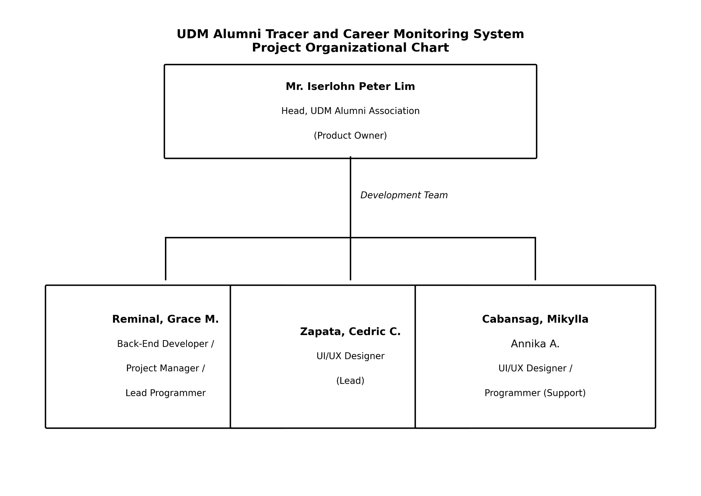
Figure 3. Organizational Chart of the UDM Alumni Tracer and
Career Monitoring System Project Team

Task Description
The research team undertook various tasks, with each member assigned specific responsibilities based on their role in the project. As the client representative and Product Owner, Mr. Iserlohn Peter Lim, Head of the UDM Alumni Association, articulated the operational needs and limitations of the University's current manual tracer process, defined and prioritized the features included in the Product Backlog, and reviewed and validated each completed sprint through the Sprint Review sessions with the research team.
The team leader, Ms. Reminal, served as the Back-End Developer, Project Manager, and Lead Programmer of the group. She coordinated the team's Sprint Planning sessions, Daily Scrum meetings, and Sprint Retrospectives throughout the development process, and took primary responsibility for the system's back-end architecture, including the server-side logic, the design of the relational database, the enforcement of the tracer survey's skip logic, and the implementation of role-based access control and data privacy safeguards consistent with the Data Privacy Act of 2012 (RA 10173). She also oversaw the overall progress and technical direction of the project.
Mr. Zapata took charge of the system's UI/UX design as the lead designer, ensuring the Alumni Portal, College Dashboard, and Admin Dashboard were intuitive, visually consistent, and mobile-responsive. He was responsible for the layout, navigation flow, and interaction design of the multi-section tracer survey, as well as the design of the dashboards' data visualizations, including the bar charts, pie charts, and line graphs used to present employability analytics.
Ms. Cabansag supported the design and development process by assisting in UI/UX design tasks alongside the lead designer and contributing to the system's programming requirements. She helped in the development of front-end components, the testing of implemented features across sprints, and the refinement of the system's interfaces based on feedback gathered during Sprint Reviews.

Operational Feasibility
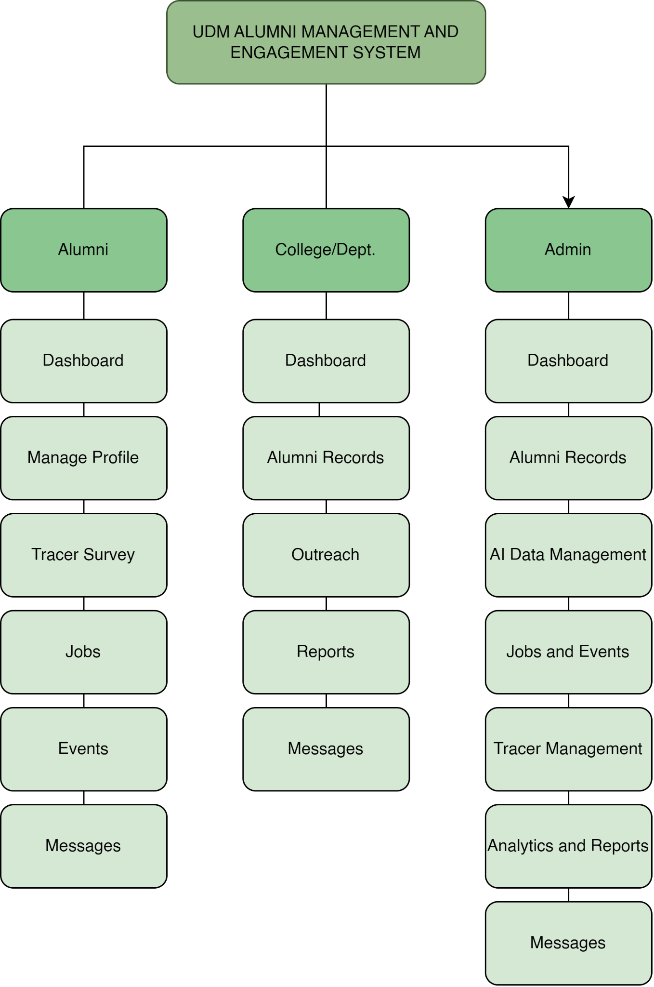
The Figure illustrates the functional decomposition of the UDM Alumni Tracer and Career Monitoring System, showing the functions available to Alumni, College/Department users, and Administrators. Alumni can manage their profiles, complete tracer surveys, update their employment information, browse job opportunities, register for events, and communicate with the Alumni Relations Office or their respective college. College/Department users can access college-specific dashboards, view and verify alumni records, conduct outreach, generate reports, and manage messages. Administrators have university-wide access to alumni records, AI Data Management for masterlist imports, job and event management, tracer questionnaire configuration, analytics, and reports. This role-based structure supports efficient alumni tracking, reduces manual reporting tasks, and ensures that access to alumni information is limited according to each user's responsibilities.

Technical Feasibility
The technical feasibility of the UDM Alumni Tracer and Career Monitoring System was assessed in terms of the availability of the required technologies, the compatibility of these technologies with one another, and the capability of the research team to develop, deploy, and maintain the proposed system within the given project timeframe.
The system will be built using widely adopted, open-source, and well-documented technologies, namely React.js and JavaScript for the front end, Node.js for server-side application logic, and MariaDB as the relational database management system. These technologies are freely available, actively maintained, and supported by extensive developer communities and documentation, reducing the technical risk associated with tool adoption and troubleshooting during development. React.js and Node.js are also designed to work well together within a single JavaScript-based stack, allowing consistent data handling between the client and server layers and simplifying the implementation of features such as the skip-logic tracer survey, real-time form validation, and dynamic chart rendering identified in the system's functional requirements.
For hosting and deployment, the system will make use of Amazon Web Services (AWS), a commercially available cloud infrastructure provider that offers scalable computing resources, managed database hosting, and standard security configurations such as access control and encrypted storage. Because AWS is a pay-as-you-scale platform, it is capable of accommodating the University's current alumni record volume of over a thousand respondents, as well as future growth in the number of alumni profiles and survey responses, without requiring the University to invest in and maintain its own physical server infrastructure. This directly supports the Performance Efficiency and Portability requirements defined in the system's non-functional requirements.
The research team likewise possesses adequate technical competence to carry out the development of the system, having relevant academic training and hands-on experience in web application development, database design, and the specific technologies chosen for the project. The Agile/Scrum methodology adopted for this study further supports technical feasibility, as it allows the researchers to develop, test, and validate the system's technical components incrementally through successive sprints, enabling technical issues to be identified and resolved early rather than at the end of the development cycle. Taken together, the availability of mature, compatible, and well-supported technologies, the scalability of the chosen cloud hosting environment, and the technical preparedness of the research team indicate that the proposed system is technically feasible to design, develop, and deploy within the scope of this study.

Schedule Feasibility
The schedule feasibility of the UDM Alumni Tracer and Career Monitoring System was assessed based on the researchers' ability to complete the design, development, and evaluation of the system within the academic timeframe allotted for the capstone project.
The project follows the Agile/Scrum framework, which organizes development into fixed-length sprints, allowing the researchers to plan, develop, and review the system in manageable, incremental phases rather than attempting to deliver the entire system at once. This iterative structure allows the research team to prioritize core modules, such as the membership and authentication module and the tracer survey engine, for development in earlier sprints, followed by the Job Opportunities Board, the Analytics and AI-Assisted Insights Module, and the report generator in subsequent sprints. Should unforeseen delays or additional requirements arise, the Agile/Scrum framework allows the product backlog to be re-prioritized without jeopardizing the overall project timeline, since each sprint delivers a working increment of the system that can be independently demonstrated and evaluated.
The researchers' use of dummy data to initially test the system's survey logic, analytics computations, and dashboard outputs, rather than waiting for the migration and cleaning of the University's existing pool of over a thousand Google Form responses, further supports schedule feasibility, as it allows development and testing activities to proceed in parallel with data preparation activities rather than in sequence. Regular Sprint Reviews and Retrospectives conducted with the Alumni Office also help ensure that feedback is incorporated promptly, reducing the likelihood of late-stage revisions that could otherwise extend the project timeline. Considering the manageable scope of the system's features, the incremental nature of the Agile/Scrum methodology, and the planned use of dummy data during early development, the project is deemed feasible to complete within the given schedule.

Economic Feasibility
The proposed UDM Alumni Tracer System is economically feasible because it uses open-source technologies and cloud-based hosting services to minimize development and operational expenses. The system is developed using React and Vite for the frontend, Node.js and Express for the backend, and PostgreSQL for database management. Railway is used as the hosting platform for deploying the system and its backend services.
The estimated expenses cover cloud hosting, domain registration, file storage, and other resources needed to deploy, test, and maintain the system. Development tools and software licenses are expected to have no additional cost because the project primarily uses open-source technologies. Email services may also be provided through the university's existing Google Workspace account, subject to availability and authorization.
These expenses are justified by the long-term benefits of the system, including centralized alumni records, automated tracer surveys, faster report generation, improved alumni engagement, and reduced manual data processing. The system can help the university and its colleges access organized alumni information more efficiently while supporting employment monitoring and institutional reporting.
Table #. Economic Feasibility of the UDM Alumni Tracer System

Cost Item | Cost (Php) | Billing Cycle | Benefits & Purpose
Railway Hosting | ₱4,200.00 | Annual | Provides cloud hosting for deploying and operating the system's frontend, backend API, and database services, subject to selected deployment configuration and resource usage.
Domain Registration | ₱1,000.00 | Annual | Provides a dedicated web address that allows alumni and authorized university personnel to access the system conveniently.
File Storage | ₱0.00 | Estimated Free Tier | Supports the storage of profile photos and employment proof documents through an eligible free-tier service, subject to storage limits and usage.
Development Tools & Software | ₱0.00 | Open-Source | Open-source technologies reduce software licensing expenses and support system development, testing, and maintenance.
Email Service | ₱0.00 | Institutional Account | An existing university email service may support password-reset messages and system notifications, subject to account availability and configuration.
Internet & Electricity Allocation | ₱1,500.00 | Project Estimate | Supports the team's development, testing, deployment, and maintenance activities.
Total Estimated Cost | ₱6,700.00 | — | Provides the essential resources for system deployment, accessibility, and continued operation.
Note: These figures are preliminary budgeting estimates for academic feasibility analysis, not confirmed expenses or supplier quotations. The Railway estimate assumes approximately ₱350 per month, while the domain and internet/electricity amounts are provisional allowances. Actual costs may vary according to resource consumption, exchange rates, service plans, and institutional arrangements.
Based on the projected expenses, the UDM Alumni Tracer System is considered economically feasible for an academic project. Its use of open-source technologies and usage-based cloud services helps reduce the initial investment compared with purchasing and maintaining dedicated server hardware. Furthermore, the expected improvements in data management, reporting efficiency, and alumni engagement provide practical benefits that can justify the system's operating costs. Before production deployment, the university should verify the actual hosting requirements, available institutional services, and recurring expenses to establish a final operating budget.

Design of Software, Systems, Products and Processes

Context Flow Diagram
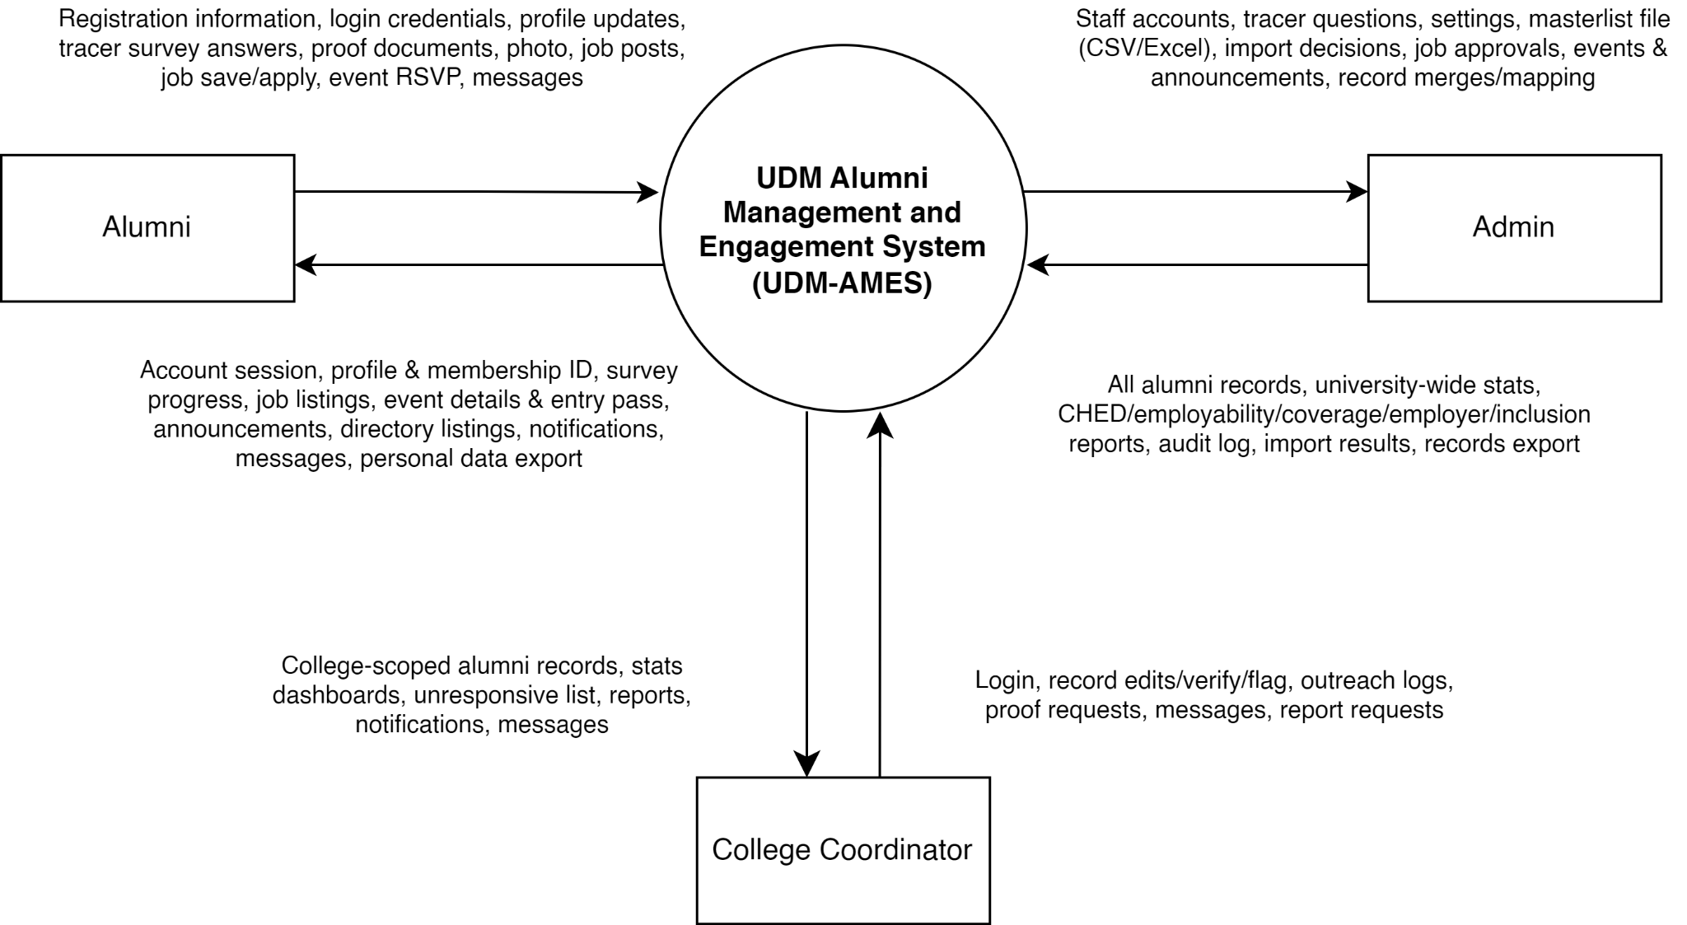
Figure 4. Context Flow Diagram of the UDM Alumni Management and Engagement System.
The Context Flow Diagram (CFD) illustrates the overall interaction between the UDM Alumni Management and Engagement System (UDM-AMES) and its three primary user roles: Alumni, Admin, and College Coordinator. It presents the information exchanged between the system and its external entities without detailing the internal processes or database structure.
The Alumni entity represents graduates who use the system to manage their personal and educational profiles, submit tracer survey responses, update employment information, upload requested proof of employment, browse and apply for job opportunities, submit job postings for review, register for events, and communicate with the Alumni Relations Office or their respective college. In return, the system provides account and registration confirmations, profile and survey status, job listings, event details, notifications, messages, and access to personal data exports.
The Admin entity represents the staff of the Alumni Relations Office responsible for university-wide system administration and alumni record management. The administrator provides account and record management requests, graduate masterlist files for import, data validation decisions, tracer survey configuration, job posting and event details, and report generation requests. The system returns alumni records, verification information, university-wide statistics, employability analytics, import results, audit logs, and generated reports and record exports. The administrator also manages job posting approvals, event registrations, announcements, and communications with alumni and college personnel.
The College Coordinator entity represents college-level personnel who access alumni information and analytical results relevant to their assigned college or department. The coordinator can review college-specific alumni records, verify records, conduct outreach to unresponsive or untraced alumni, communicate with alumni and the Alumni Relations Office, and generate or export college-level reports. In return, the system provides college-scoped alumni records, dashboard statistics, employability insights, outreach information, notifications, messages, and report results. Access to alumni records, statistics, and reports is restricted to the coordinator's assigned college.
The system exchanges information with these entities through clearly defined data flows. Incoming flows represent information, requests, and updates submitted to the system, while outgoing flows represent processed information, records, analytical results, confirmations, and other responses provided to the users. Role-based access controls determine which information and functions are available to each entity.
Overall, the Context Flow Diagram establishes the boundaries of UDM-AMES and presents its primary information exchanges. It demonstrates how the system centralizes alumni information management, tracer survey collection, graduate employability monitoring, career opportunity sharing, event participation, communication, and institutional reporting to support alumni engagement and data-driven decision-making at the Universidad de Manila..

Data Flow Diagram
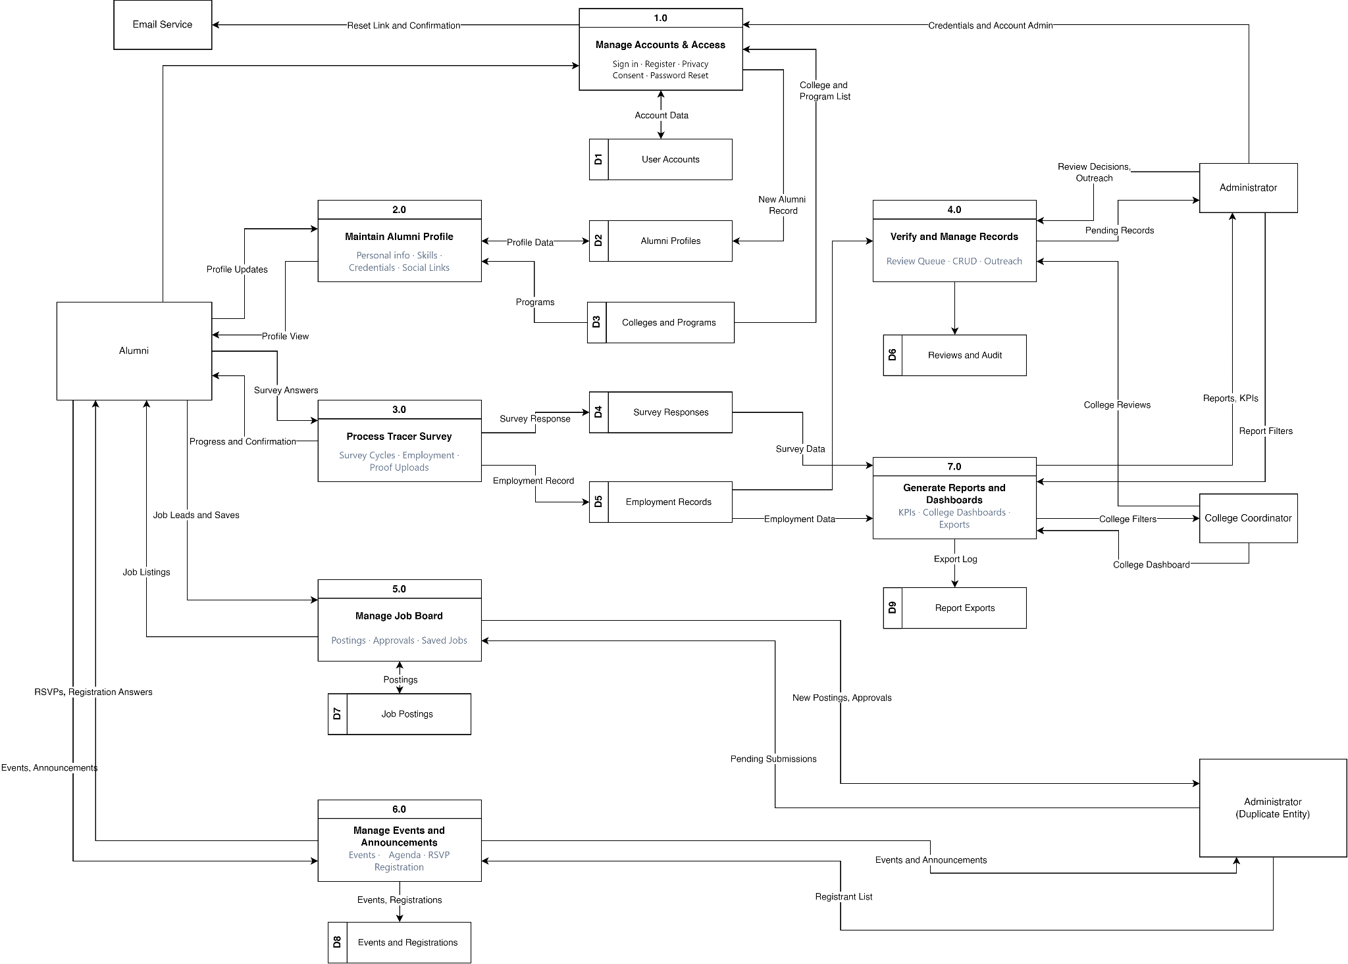
Figure 5. Data Flow Diagram of the UDM Alumni Tracer and Career Monitoring System.
The Data Flow Diagram (DFD) illustrates how data moves throughout the UDM Alumni Tracer System, including the interactions between external entities, system processes, and data stores. It presents the system's major processes, the information exchanged between users and the system, and how alumni-related data is stored, processed, and retrieved. The diagram consists of seven main processes, nine data stores, and external entities that support alumni management, administrative operations, and institutional reporting.
The Manage Accounts & Access (Process 1.0) handles user authentication, alumni registration, privacy consent, and password reset functionality. It processes account information and stores or retrieves data from the User Accounts (D1) data store. It also coordinates with the external Email Service to send password reset links and confirmation messages. Newly registered alumni information is forwarded to the Alumni Profiles (D2) data store, while the Colleges and Programs (D3) data store provides the relevant academic program information.
The Maintain Alumni Profile (Process 2.0) manages alumni profile information, including personal information, skills, credentials, and social links. Alumni can submit profile updates and view their profile information through this process. The system exchanges profile data with the Alumni Profiles (D2) data store and retrieves relevant college and program information from the Colleges and Programs (D3) data store to maintain alumni records.
The Process Tracer Survey (Process 3.0) manages tracer survey activities, including survey cycles, employment information, and employment proof uploads. Alumni submit their survey answers, while the system provides progress updates and confirmation of their submissions. Survey responses are stored in the Survey Responses (D4) data store, while employment-related information is recorded in the Employment Records (D5) data store. These records provide information needed to monitor graduate employment outcomes.
The Verify and Manage Records (Process 4.0) handles the review and maintenance of alumni records. The Administrator reviews pending records, performs record management operations, and conducts outreach activities through this process. Review decisions and related information are exchanged with the Administrator, while review activities are recorded in the Reviews and Audit (D6) data store. This process helps maintain the accuracy and reliability of alumni information.
The Manage Job Board (Process 5.0) handles job postings, approvals, and saved jobs. Alumni can access available job listings and manage saved opportunities, while the Administrator handles job posting submissions and approval-related activities. Job posting information is stored in the Job Postings (D7) data store, supporting the management and distribution of career opportunities to alumni.
The Manage Events and Announcements (Process 6.0) manages university events, announcements, event agendas, registrations, and RSVP information. Alumni can view events and announcements, submit registration details, and provide RSVP responses. The system processes event registrations and maintains the corresponding records in the Events and Registrations (D8) data store. The Administrator manages event information and accesses registrant lists to support event coordination and alumni engagement.
The Generate Reports and Dashboards (Process 7.0) consolidates survey responses, employment records, and other relevant information to produce key performance indicators (KPIs), college dashboards, and report exports. The Administrator can request reports and provide report filters, while the College Coordinator can apply college-specific filters and access the corresponding college dashboard. Generated reports and export activities are recorded in the Report Exports (D9) data store. This process supports institutional monitoring, evaluation, and data-driven decision-making.
The diagram identifies the Alumni, Administrator, College Coordinator, and Email Service as external entities that exchange information with the system. The Administrator oversees account-related administration, record verification, job postings, events, and reporting activities. The College Coordinator accesses college-level dashboards and applies relevant filters to review alumni outcomes within their assigned academic context. The Email Service supports account-related communications, particularly password resets and confirmation messages.
Overall, the Data Flow Diagram provides a structured overview of how the UDM Alumni Tracer System processes and manages information across its major functional areas. It demonstrates the flow of data from alumni registration and profile maintenance to tracer surveys, employment records, job opportunities, event participation, record verification, and institutional reporting. Through these interconnected processes and data stores, the system supports the centralized management of alumni information and provides relevant data for monitoring graduate outcomes and strengthening alumni engagement at the Universidad de Manila.

Use Case Diagram
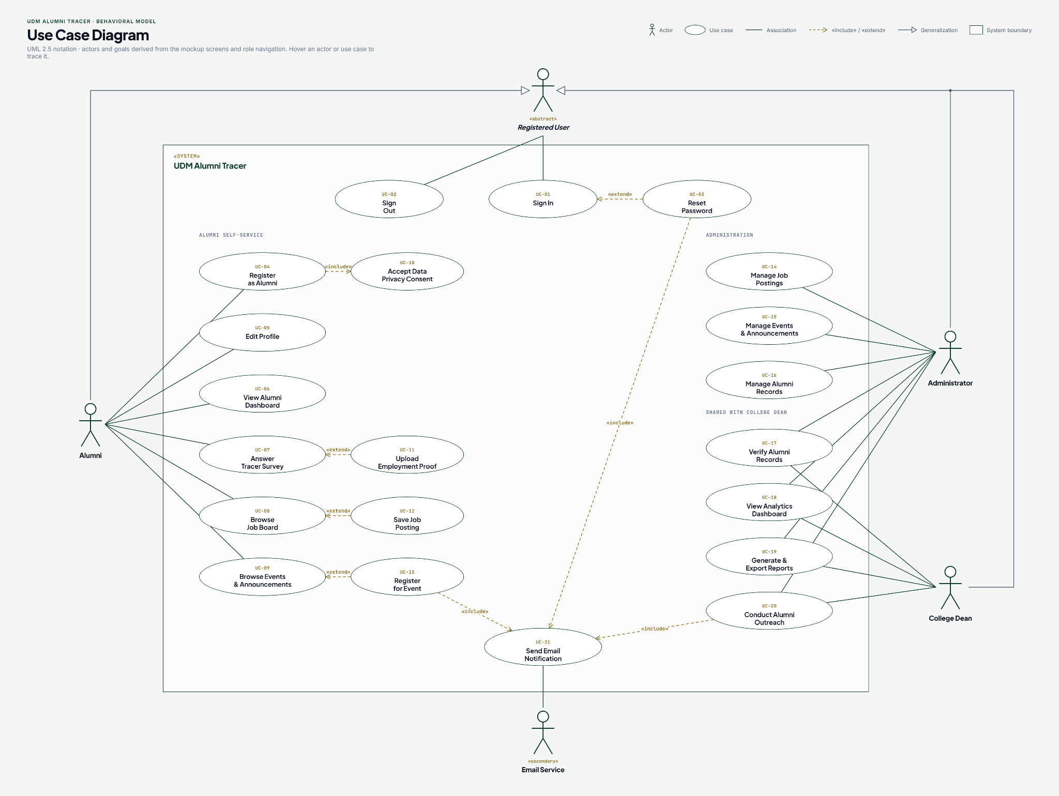
Figure 6. Use Case Diagram of the UDM Alumni Tracer and Career Monitoring System.
The Use Case Diagram illustrates the functional requirements of the UDM Alumni Tracer System and the interactions between its users and the system. It follows the Unified Modeling Language (UML) 2.5 notation to present the system's major functionalities, the actors involved, and the relationships between different use cases. The diagram identifies four primary actors: Registered User, Alumni, Administrator, and College Dean, along with an external Email Service that supports the system's email notification functionality.
The Registered User represents users who can access the authentication features of the system, including signing in, signing out, and resetting their passwords. The Alumni actor represents graduates who can register as alumni, edit their profiles, view their alumni dashboard, answer tracer surveys, browse job postings, and view events and announcements. Alumni can also upload employment proof when responding to tracer surveys, save job postings, and register for events. These activities help maintain updated alumni information, monitor employment outcomes, and encourage continued engagement with the university. The registration process includes accepting the privacy consent requirements to support responsible handling of alumni data.
The Administrator is responsible for managing the system's operational data and maintaining its content. The administrator can manage job postings, events and announcements, alumni records, and verify alumni records. Additional administrative functions include viewing the analytics dashboard, generating and exporting reports, and conducting alumni outreach activities. The College Dean shares access to selected administrative functions, particularly alumni record verification, analytics, report generation and export, and alumni outreach. These functions support institutional monitoring, informed decision-making, and the evaluation of alumni employment and engagement outcomes.
The diagram also illustrates the use of UML relationships. The `<<include>>` relationship represents functionality that is required as part of another use case, such as accepting data privacy consent during alumni registration and sending email notifications when required by supported activities. The `<<extend>>` relationship represents optional or conditional functionality, such as resetting a password from the sign-in process, uploading employment proof when answering a tracer survey, saving a job posting while browsing available opportunities, and registering for an event while browsing announcements. Generalization is used to represent the relationship between the Registered User and the more specific user roles, indicating shared authentication capabilities. Finally, the Email Service is modeled as an external supporting actor that interacts with the Send Email Notification use case.
Overall, the Use Case Diagram provides an overview of the UDM Alumni Tracer System's scope and role-based functionalities. It demonstrates how alumni, administrators, and the college dean interact with the system to manage alumni information, monitor graduate outcomes, support career opportunities, organize university events, and facilitate data-driven alumni engagement.

Activity Diagram

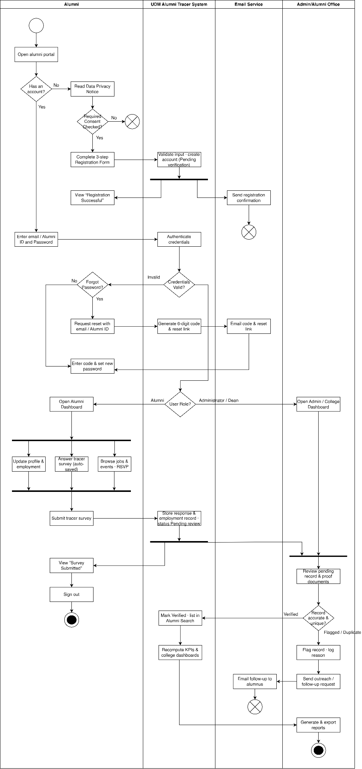
Figure 7. Activity Diagram of UDM Alumni Tracer System
The activity diagram illustrates the workflow of the UDM Alumni Tracer System, covering alumni registration, authentication, profile management, tracer survey submission, record verification, alumni outreach, and report generation. It consists of four swimlanes: Alumni, UDM Alumni Tracer System, Email Service, and Admin/Alumni Office, which represent the responsibilities and interactions of each participant throughout the process.
The process begins when an alumnus opens the alumni portal. The system checks whether the alumnus already has an account. If the alumnus does not have an account, they must read the Data Privacy Notice and provide the required consent before completing the three-step registration form. The system validates the submitted information, creates an account with a pending verification status, and displays a registration confirmation. A registration confirmation email is also sent through the Email Service.
After registration or when returning to the portal, the alumnus enters their email address or Alumni ID and password. The system authenticates the credentials and determines whether they are valid. If the credentials are invalid, the alumnus may attempt to log in again or request a password reset. For password recovery, the system generates a six-digit verification code and reset link, which are sent through the Email Service. The alumnus then enters the code and sets a new password before proceeding.
Upon successful authentication, the system identifies the user's role and redirects them to the appropriate dashboard. Alumni are directed to the Alumni Dashboard, while administrators or authorized college representatives access the Admin/College Dashboard. From the Alumni Dashboard, users can update their profile and employment information, answer the tracer survey, and browse job opportunities and events or register for events.
After the alumnus submits the tracer survey, the system stores the survey responses and employment records with a pending review status. The alumnus receives a survey submission confirmation and may sign out. Meanwhile, the Admin/Alumni Office reviews pending records and supporting proof documents to determine whether the information is accurate and unique. Verified records are marked accordingly, included in Alumni Search, and used to recompute key performance indicators (KPIs) and college dashboard statistics.
If a record is flagged or identified as a possible duplicate, the administrator records the reason and initiates an outreach or follow-up request. The Email Service sends the corresponding follow-up email to the alumnus when necessary. These activities support the validation and maintenance of accurate alumni information.
Finally, authorized personnel generate and export reports using the available alumni records, tracer survey responses, employment information, and updated statistics. These reports support the monitoring of alumni engagement, survey participation, graduate employment outcomes, and record verification.
Overall, the activity diagram presents the sequence of activities and interactions among alumni, the UDM Alumni Tracer System, the Email Service, and the Admin/Alumni Office. It demonstrates how the system facilitates alumni information management, tracer survey processing, record verification, communication, and institutional reporting.

System Diagram
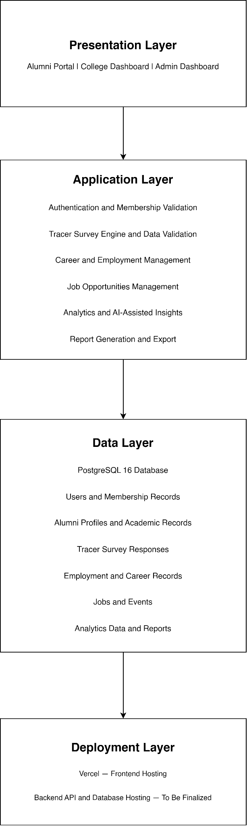
Figure 8. System Diagram of the UDM Alumni Tracer and Career Monitoring System
The UDM Alumni Tracer and Career Monitoring System is organized into four layers: Presentation Layer, Application Layer, Data Layer, and Deployment Layer. Each layer has a specific responsibility to ensure that the system supports alumni registration, tracer surveys, career monitoring, and administrative reporting.
Presentation Layer. The Presentation Layer serves as the user interface of the system. It provides separate interfaces for Alumni, College / Department users, and Administrators. Alumni can register, manage their profiles, complete tracer surveys, and access job opportunities and events. College / Department users can monitor alumni records and view college-specific reports, while Administrators manage system-wide records, jobs, events, and reports.
Application Layer. The Application Layer handles the system's core business logic and processes user requests. It includes authentication and authorization, tracer survey management, data validation, alumni profile and employment management, job and event management, analytics, and report generation. It ensures that information is processed correctly and that access to records and system functions follows the permissions assigned to each user role.
Data Layer. The Data Layer uses PostgreSQL 16 as the relational database management system for storing and managing the system's information. It contains user accounts, alumni profiles, academic records, tracer survey responses, employment records, job postings, event information, and data required for analytics and reports. The database provides a centralized source of information for the system's operations and reporting functions.
Deployment Layer. The Deployment Layer describes the environment in which the system is hosted and made accessible to users. Vercel is designated for frontend hosting, allowing users to access the web application through a browser. The hosting arrangement for the backend API and PostgreSQL database remains to be finalized. These components must be deployed in compatible environments and configured to communicate securely.
Overall, the four-layer architecture separates the user interface, application processing, data storage, and hosting environment. This separation supports maintainability, security, and future system improvements while keeping the implementation aligned with the product requirements.

Front End
The front-end development of the UDM Alumni Tracer System was implemented using React 18, JavaScript, Vite 5, React Router 6, and custom CSS, following a component-based architecture that supports reusable interface elements across the Alumni Portal, College or Department Portal, and Admin Portal. Major interface components include authentication and registration forms, profile management forms, the multi-step tracer survey, job listing cards, event components, data tables, dashboard cards, charts, and modal dialogs. These components provide consistent functionality and appearance across the system while supporting maintainability and incremental development.
The Alumni Tracer Survey was integrated into the alumni profile module as a step-by-step form with progress tracking. The form uses information collected during registration to prefill applicable fields, allowing alumni to review and edit their responses before submission. Conditional rendering is implemented to display only the questions relevant to the respondent's answers, including employment details, self-employment information, reasons for unemployment, and marital-status-related fields. Unsubmitted survey drafts are retained in the browser, while submitted responses are stored in the database through the backend API. Client-side validation provides immediate feedback on required fields and input formats, complementing the validation performed by the server.
The College and Admin dashboards present database-backed statistics and employability insights through reusable cards, tables, and chart components. The College Portal displays statistics limited to the college assigned to the authenticated account, while the Admin Portal provides authorized access to university-wide indicators, including alumni registrations, tracer survey coverage, employment rates, and recent system activity. Reports and alumni record tables support searching, filtering, sorting, and server-side pagination where applicable. The interface also incorporates job listings, event registration, notifications, global alumni search, profile completion indicators, and status badges to support alumni engagement and administrative operations.
The system follows the approved UDM visual design, preserving the green and gold color palette, off-white backgrounds, typography, card styling, sidebar navigation, status indicators, and progress indicators. Responsive layouts support access through desktop computers, tablets, and mobile devices. Accessibility considerations include keyboard-navigable forms and dialogs, sufficient color contrast, and accessibility testing. The frontend communicates with the backend through the centralized API client located at client/src/lib/api.js, using the same-origin /api/v1 endpoint. This integration allows the interface to retrieve and update information through the backend rather than relying on hardcoded production statistics.

Back End
The backend of the UDM Alumni Tracer System was developed using Node.js 20 or later and Express 5 to handle application logic, authentication, alumni registration, profile management, tracer survey processing, employment information, reporting, and other system operations through RESTful API endpoints. Zod is used for request validation, while Pino supports application logging. The API is organized around the system's principal modules, including authentication, alumni records, tracer survey responses, statistics, reports, outreach, job postings, events, notifications, file management, and audit logging.
Authentication supports sign-in using an email address or Alumni ID and password. The backend uses Argon2id for password hashing and maintains opaque server-side sessions through HttpOnly cookies configured with appropriate security attributes. Password recovery uses single-use, expiring reset tokens and verification codes delivered through email. Rate limiting, account lockout after repeated failed login attempts, generic invalid-credential messages, and session revocation are implemented as security requirements. The backend also enforces role-based access control for Alumni, College or Department, and Admin accounts. College access is restricted to the account's assigned college through server-side authorization and data scoping, while administrators are permitted to access university-wide functions according to their assigned role.
The relational database is implemented using PostgreSQL 16, with database migrations managed through node-pg-migrate. The database consists of a 28-table schema based on the system's Entity-Relationship Diagram, together with supporting statistics views. Database tables and lookup records manage alumni profiles, educational backgrounds, tracer survey responses, employment information, user accounts, job postings, events, and other system entities. College and program lookup tables serve as the authoritative data sources for registration, profile management, filtering, and reporting. Server-side validation complements frontend validation to ensure that submitted information follows the system's requirements. Record-management functions also support verification, flagging, archiving, duplicate merging, and bulk import. Merged and archived records are excluded from applicable system statistics.
The backend processes tracer survey responses and employment information to generate statistics for the dashboards and reports. These include tracer survey coverage, employment rates, employability by program, batch coverage, employer and industry distribution, and inclusion profiles. Statistics are computed on the server using consistent database views and queries to maintain data consistency across the Alumni Portal, College Portal, Admin Portal, and reporting functions. Reports support PDF, Excel, and CSV exports, with each export recorded in the report history and audit log. Sensitive personal information is restricted to authorized roles, inclusion reports present aggregated counts, and employer and industry reports do not disclose named alumni.
Data privacy and security are incorporated into backend operations in accordance with the Philippine Data Privacy Act of 2012 (Republic Act No. 10173). The system requires explicit consent during registration, applies opt-in settings for alumni directory visibility, and displays only the contact channels that alumni have chosen to make visible. Uploaded files are validated according to file type and size requirements, while private documents are served through signed URLs. Notifications are generated by the backend for relevant system activities, with read status stored per user. Audit logging records failed login attempts, sensitive data access, record modifications, and report exports. Scheduled maintenance tasks support tracer coverage alerts, notification retention, and expired-token cleanup.
For deployment, the frontend is intended to be hosted on Vercel, while the backend API, PostgreSQL database, and production file storage are hosted separately using appropriate hosting infrastructure. An API rewrite is configured to route frontend requests to the backend through the same-origin /api path, supporting session-cookie handling. Email delivery is designed to use the Gmail API through a Google Workspace service account in production, with an SMTP fallback where configured and a console-based driver for development. The system is designed to undergo browser-based end-to-end testing against the running API before production deployment.

Unit Testing

Test Case
The study utilized both White Box and Black Box Testing methods to evaluate the UDM Alumni Tracer and Career Monitoring System. White Box Testing was conducted by the developer, the quality assurance specialist, and the debugger among the research team. The developer built the system's core modules based on the project's defined functional and non-functional objectives and tested their internal logic during development. The quality assurance specialist reviewed the system's code, interface components, and data visualizations for adherence to the project's design and quality standards. The debugger traced the system's internal logic to identify hidden or semantic errors in the tracer survey's skip-logic rules, validation routines, and analytics computation functions.
Meanwhile, Black Box Testing was performed by the remaining researchers, who acted as survey facilitators and system demonstrators to the Head of Alumni, college coordinators, and sample alumni respondents. They provided an overview of the system's features and functions, gathered feedback through survey questionnaires for further improvement, and observed user experiences and difficulties encountered during hands-on interaction with the Alumni Portal, College Dashboard, and Admin Dashboard. These observations and insights were critical for assessing and refining the system's overall performance prior to its formal ISO/IEC 25010 evaluation.

Table 1. Black Box Test Cases for the UDM Alumni Tracer and Career Monitoring System
TC ID | Test Scenario | Test Steps / Input | Expected Result | Actual Result | Status
TC-01 | Register a new alumni account with a valid Alumni Membership ID | 1. Go to the registration page. 2. Enter a valid, existing Alumni Membership ID. 3. Complete name, email, password, and required fields. 4. Submit the form. | System validates the Membership ID against Alumni Office records, creates a new account, and redirects the user to the Alumni Portal dashboard. | As expected. | Passed
TC-02 | Register using a non-existent or invalid Alumni Membership ID | 1. Go to the registration page. 2. Enter a Membership ID not found in Alumni Office records. 3. Complete remaining fields. 4. Submit the form. | System rejects the submission and displays an error message indicating the Membership ID could not be verified. No account is created. | As expected. | Passed
TC-03 | Register using a Membership ID already linked to an existing account | 1. Enter a Membership ID that already has a registered account. 2. Complete the remaining fields. 3. Submit the form. | System displays a duplicate-account error and prevents a second account from being created for the same Membership ID. | As expected. | Passed
TC-04 | Log in with valid credentials | 1. Go to the login page. 2. Enter a registered email/Membership ID and correct password. 3. Click Log In. | System authenticates the user and redirects to the role-appropriate landing page (Alumni Portal for alumni accounts). | As expected. | Passed
TC-05 | Log in with an incorrect password | 1. Enter a registered email/Membership ID. 2. Enter an incorrect password. 3. Click Log In. | System denies access and displays an “incorrect credentials” message without revealing whether the account exists. | As expected. | Passed
TC-06 | Update personal profile information | 1. Log in as an alumnus. 2. Navigate to Manage Profile. 3. Edit address, email, Facebook Messenger, and affiliations. 4. Save changes. | System validates and saves the updated fields, and the profile page reflects the new information immediately. | As expected. | Passed
TC-07 | Submit tracer survey as an employed respondent | 1. Log in and open the Tracer Survey. 2. Select “Employed” in the employment-status section. 3. Complete the succeeding sections. 4. Submit the survey. | Skip logic hides self-employment-only sections; only employment-related sections relevant to a hired employee are shown. Survey is saved and a submission acknowledgment is displayed. | As expected. | Passed
TC-08 | Submit tracer survey as a self-employed respondent | 1. Open the Tracer Survey. 2. Select “Self-Employed.” 3. Complete the self-employment section. 4. Submit the survey. | Skip logic redirects the flow to self-employment fields and hides company-employment fields (e.g., employer name, immediate supervisor). Submission is saved successfully. | As expected. | Passed
TC-09 | Submit tracer survey with required fields left blank | 1. Open the Tracer Survey. 2. Leave one or more required fields empty. 3. Attempt to submit. | System blocks submission, highlights the missing required fields, and displays a validation message. No incomplete record is saved. | As expected. | Passed
TC-10 | Submit tracer survey with a boundary-value input (e.g., monthly income at bracket edge) | 1. Open the Tracer Survey. 2. Enter an income value exactly at the boundary between two income brackets. 3. Submit the survey. | System correctly classifies the value into the appropriate bracket with no rounding or off-by-one errors, and the survey is submitted successfully. | As expected. | Passed
TC-11 | Save and resume an incomplete tracer survey | 1. Begin the Tracer Survey and complete several sections. 2. Close the browser without finishing. 3. Log back in and reopen the survey. | System restores the respondent's previously entered answers and resumes at the last incomplete section rather than restarting from the beginning. | As expected. | Passed
TC-12 | Update employment/career details after initial survey submission | 1. Log in as an alumnus with a previously submitted survey. 2. Go to Update Employment Details. 3. Change employer, job title, and employment status. 4. Save. | System stores the new employment record as an update to the alumnus's longitudinal career history without overwriting prior historical entries. | As expected. | Passed
TC-13 | Browse the Job Opportunities Board | 1. Log in as an alumnus. 2. Navigate to the Job Opportunities Board. | System displays currently active job postings with employer, position, and posting date; expired or removed postings are not shown. | As expected. | Passed

College Dashboard
TC ID | Test Scenario | Test Steps / Input | Expected Result | Actual Result | Status
TC-14 | College coordinator views employability analytics for their own college | 1. Log in as a college coordinator account. 2. Open the College Dashboard. | System displays employment rate, course-job alignment, and industry distribution charts filtered to the coordinator's assigned college and programs only. | As expected. | Passed
TC-15 | College coordinator attempts to access another college's data | 1. Log in as a coordinator for College A. 2. Attempt to change the dashboard filter/URL parameter to College B. | System blocks the request and displays an access-denied message; no data from College B is returned. | As expected. | Passed

Admin Dashboard
TC ID | Test Scenario | Test Steps / Input | Expected Result | Actual Result | Status
TC-16 | Administrator validates a pending alumni membership record | 1. Log in as an Alumni Office administrator. 2. Open the pending records queue. 3. Review and approve a pending record. | Record status changes to “Verified” in the database, and the corresponding alumni account gains full portal access. | As expected. | Passed
TC-17 | Administrator creates and publishes a new tracer survey question | 1. Log in as an administrator. 2. Open Manage Survey Questions. 3. Add a new question with its skip-logic condition. 4. Publish the update. | New question appears in the live survey for future respondents, and the skip-logic condition is enforced correctly. | As expected. | Passed
TC-18 | Administrator posts a new job opportunity listing | 1. Log in as an administrator. 2. Open Manage Job Postings. 3. Fill in employer, position, and description fields. 4. Publish the listing. | Job listing is saved and immediately becomes visible on the alumni-facing Job Opportunities Board. | As expected. | Passed
TC-19 | Administrator generates a university-wide employability report | 1. Log in as an administrator. 2. Open Generate Reports. 3. Select a reporting period and college scope (all colleges). 4. Generate the report. | System compiles and outputs an accurate, correctly formatted report summarizing employment rate, industry distribution, and related indicators across all colleges. | As expected. | Passed
TC-20 | Non-administrator account attempts to access an admin-only endpoint | 1. Log in using a regular alumni account. 2. Attempt to directly navigate to an Admin Dashboard URL/endpoint (e.g., Manage Alumni Records). | System denies access based on role-based access control and redirects the user or displays an authorization error. No administrative data is exposed. | As expected. | Passed
TC-21 | Administrator attempts to export raw personal data outside the reporting module | 1. Log in as an administrator. 2. Attempt to trigger a raw data export from a module other than the sanctioned reporting module. | System restricts the export in accordance with RA 10173 safeguards, permitting export only through the authorized reporting module and only in aggregated/report form. | As expected. | Passed

Analytics and AI-Assisted Insights
TC ID | Test Scenario | Test Steps / Input | Expected Result | Actual Result | Status
TC-22 | System computes employment rate from stored survey data | 1. Populate the database with a known set of dummy survey responses (employed vs. unemployed counts). 2. Open the Analytics module. | Displayed employment rate matches the value manually calculated from the same dataset. | As expected. | Passed
TC-23 | System highlights notable employability trends via AI-assisted insights | 1. Populate the database with sample multi-year survey data showing a clear trend (e.g., a declining employment rate for one program). 2. Open the Analytics & AI-Assisted Insights module. | System correctly surfaces the declining-trend insight for the affected program among its highlighted notable trends. | As expected. | Passed

Table 2. Summary of Unit Tests Conducted under White Box Testing
Component / Function Tested | Unit Test Description | Tool Used | Result
Tracer Survey skip-logic engine | Traced each conditional branch of the skip-logic rules (employed / self-employed / unemployed paths) to confirm that every combination of employment-status answers renders only the correct set of downstream sections. | Jest | Passed
Form/input validation functions | Verified required-field checks, email and contact-number format validation, and Alumni Membership ID format validation against valid, invalid, and boundary inputs. | Jest | Passed
Authentication service | Tested password hashing/verification, session/token issuance, and rejection of invalid or expired credentials at the function level. | Jest + Supertest | Passed
Role-based access control (RBAC) middleware | Verified that middleware correctly allows or denies access for each of the three roles (alumni, college coordinator, administrator) across representative protected routes. | Jest + Supertest | Passed
Employment rate computation function | Fed a range of sample record sets (including zero-respondent and all-unemployed edge cases) into the employment-rate function and compared output against manually computed values. | Jest | Passed
Time-to-employment computation function | Verified correct date-difference calculation between graduation date and first-employment date, including cases with missing or not-yet-employed records. | Jest | Passed
Course-job alignment percentage function | Confirmed correct classification and percentage calculation of job-to-degree relevance across sample survey responses. | Jest | Passed
Database query functions (alumni profiles, survey responses) | Tested CRUD query functions against a test MariaDB instance to confirm correct filtering, joins across related tables, and correct handling of empty result sets. | Jest + mysql2 test connection | Passed
Sensitive-field encryption/decryption routines | Verified that designated sensitive fields (e.g., contact information, addresses) are correctly encrypted before storage and correctly decrypted for authorized display. | Jest | Passed

Output and User Interface Design
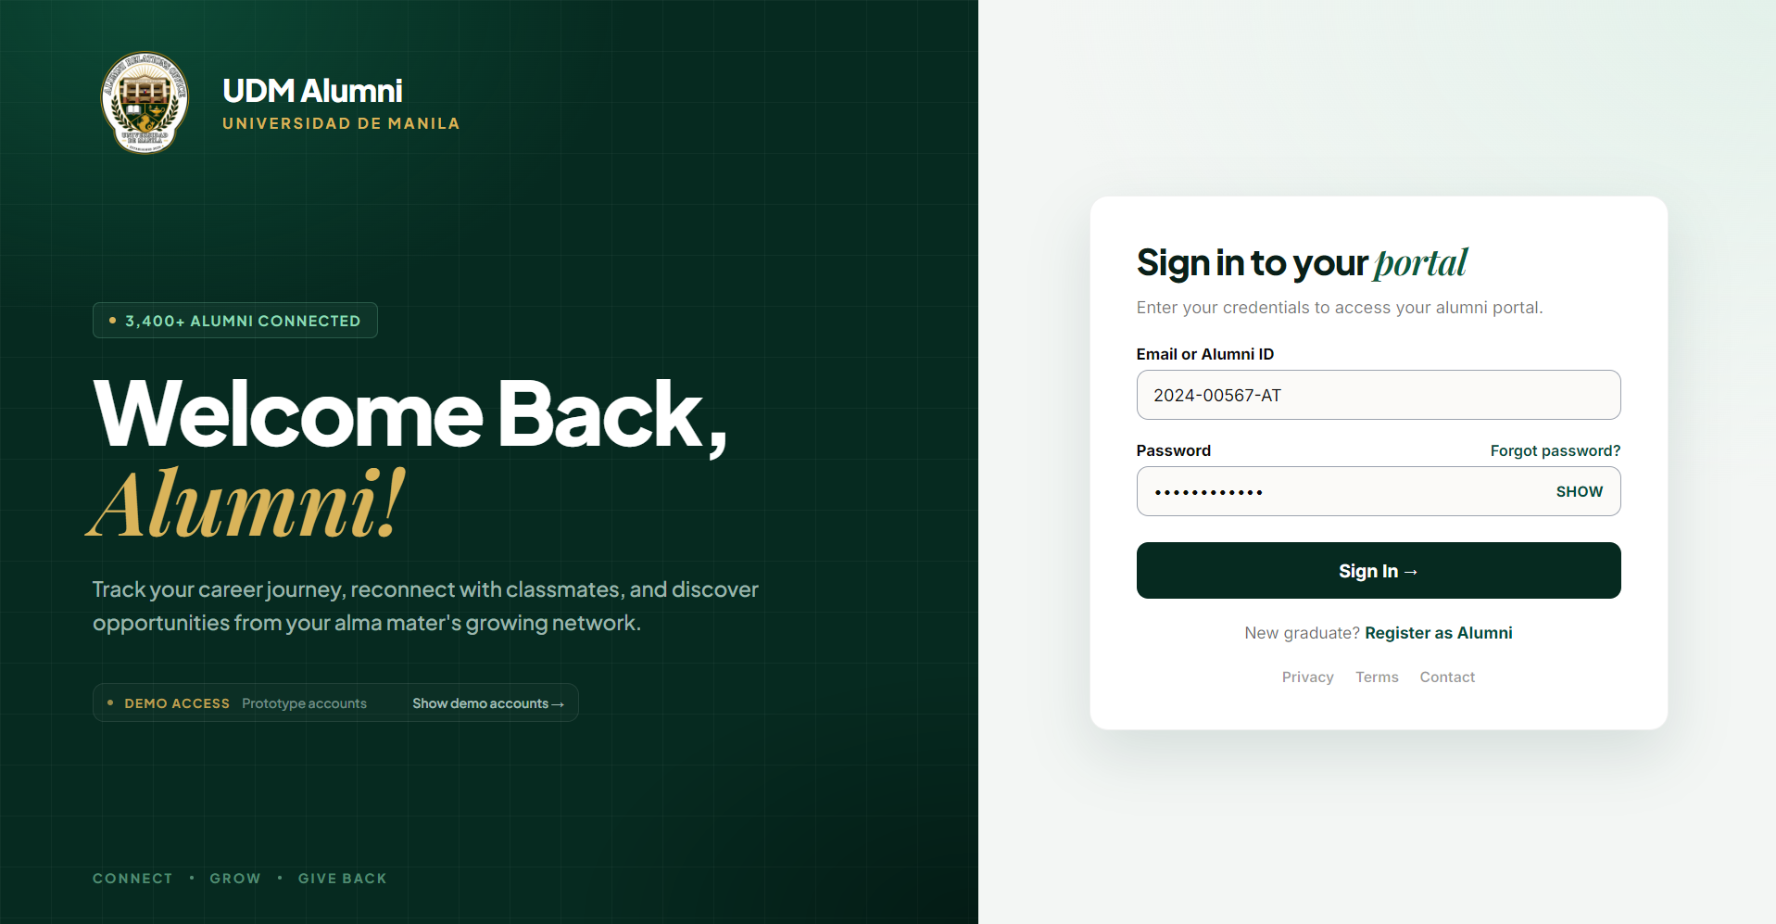
Figure 9. Sign-in page. Users enter their Email or Alumni ID and password.
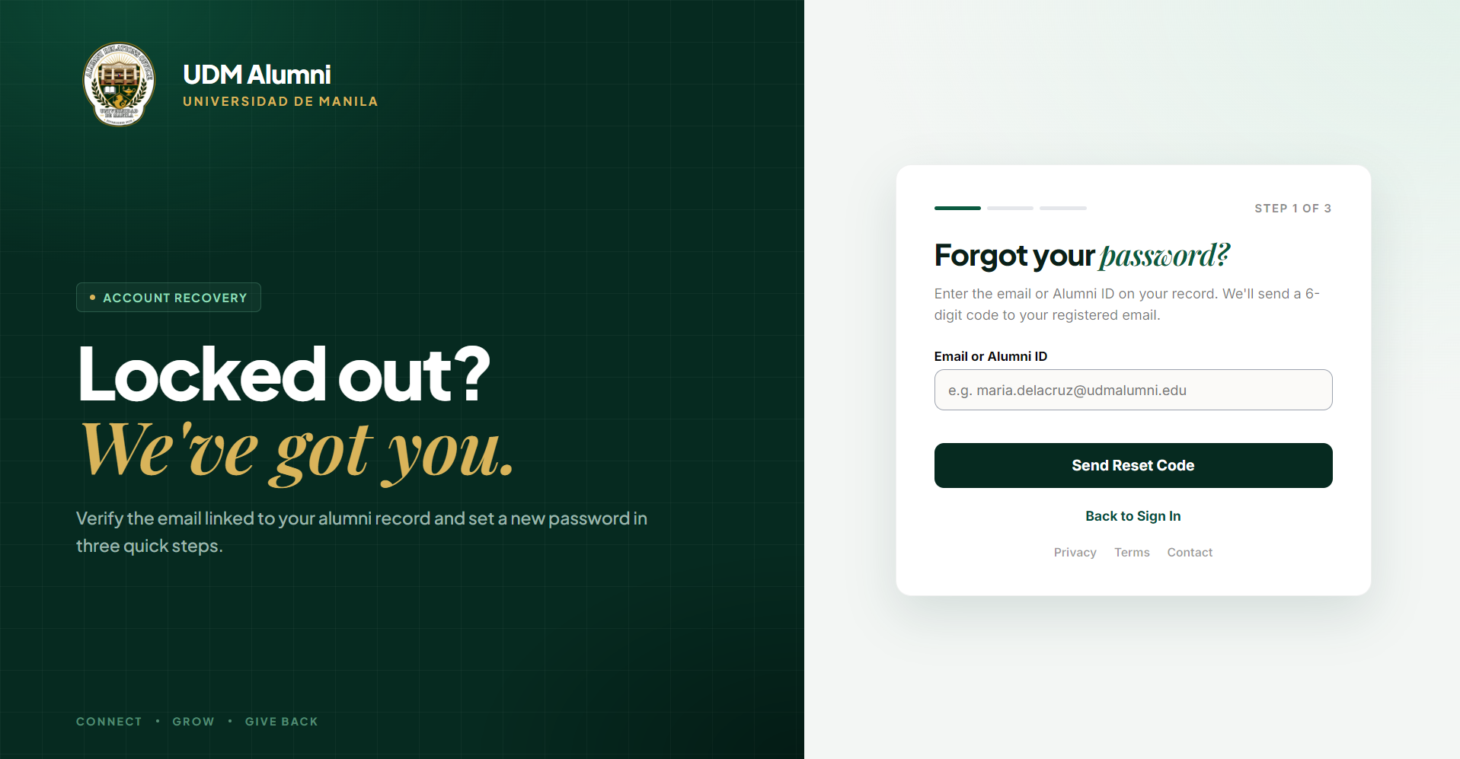
Figure 10. Illustrates the Account Recovery interface. It provides a three-step recovery process where users can enter their registered email address or Alumni ID to receive a 6-digit verification code and reset their password.
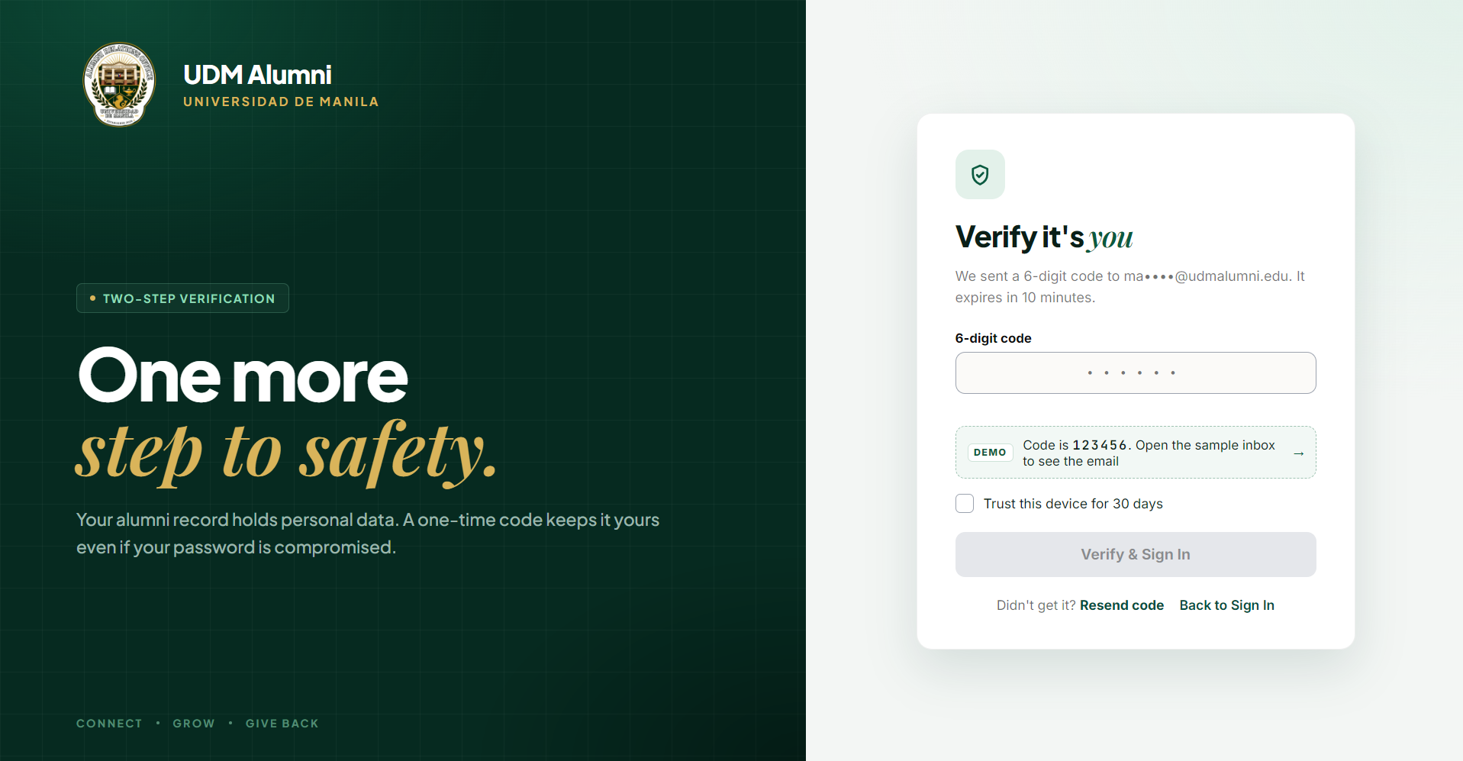
Figure 11. The two-step verification interface, where users enter a 6-digit verification code sent to their registered email to securely sign in to their account.
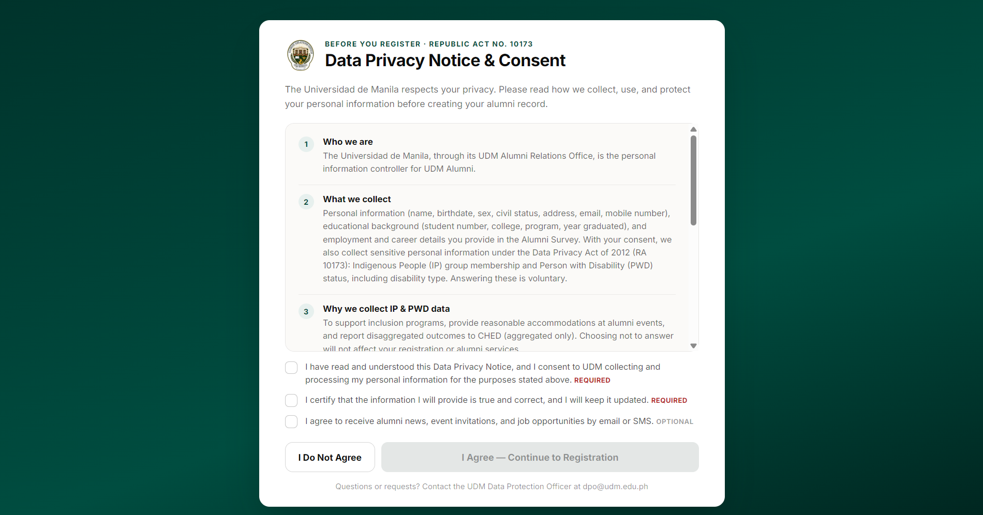
Figure 12. illustrates the Data Privacy Notice & Consent interface presented to alumni before registration, complying with Republic Act No. 10173 (Data Privacy Act of 2012).
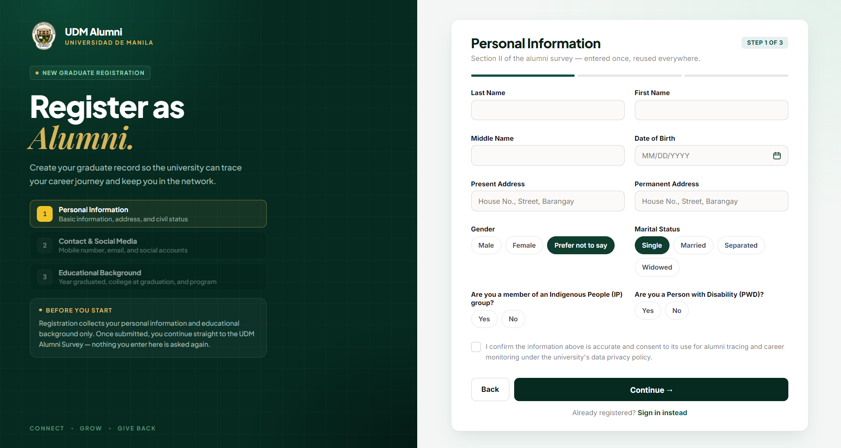
Figure 13. Register Page. New alumni user fill out their details to create an account.
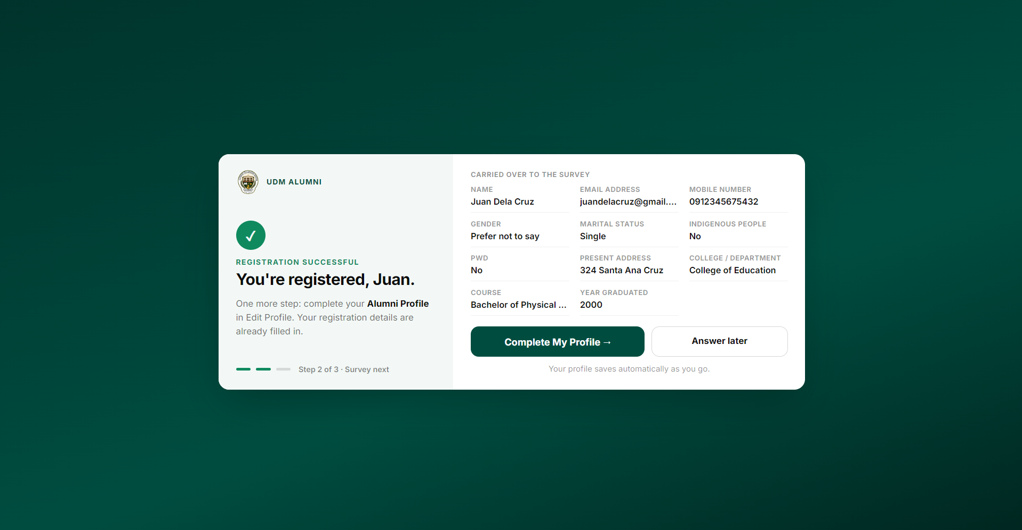
Figure 14. Registration Confirmation Page. Alumni receive submission confirmation.
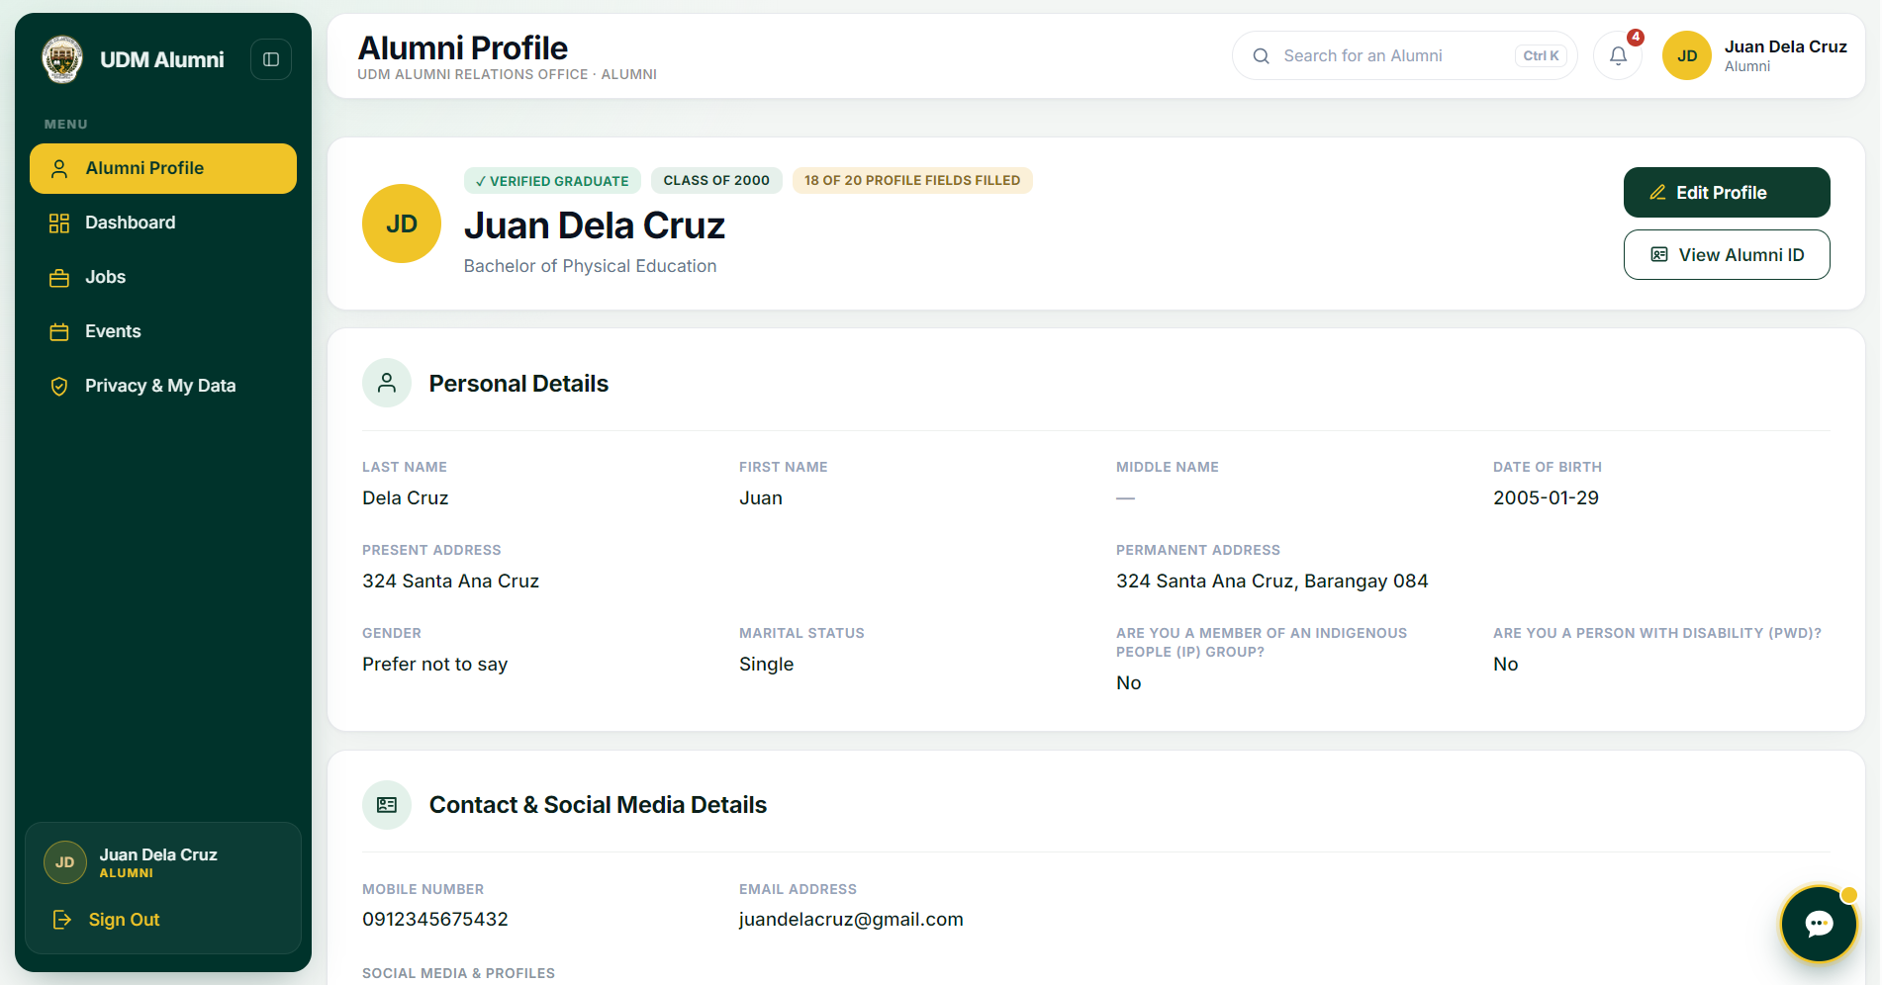
Figure 15. the Alumni Profile interface, where users can view and manage their personal details, contact information, and account status.
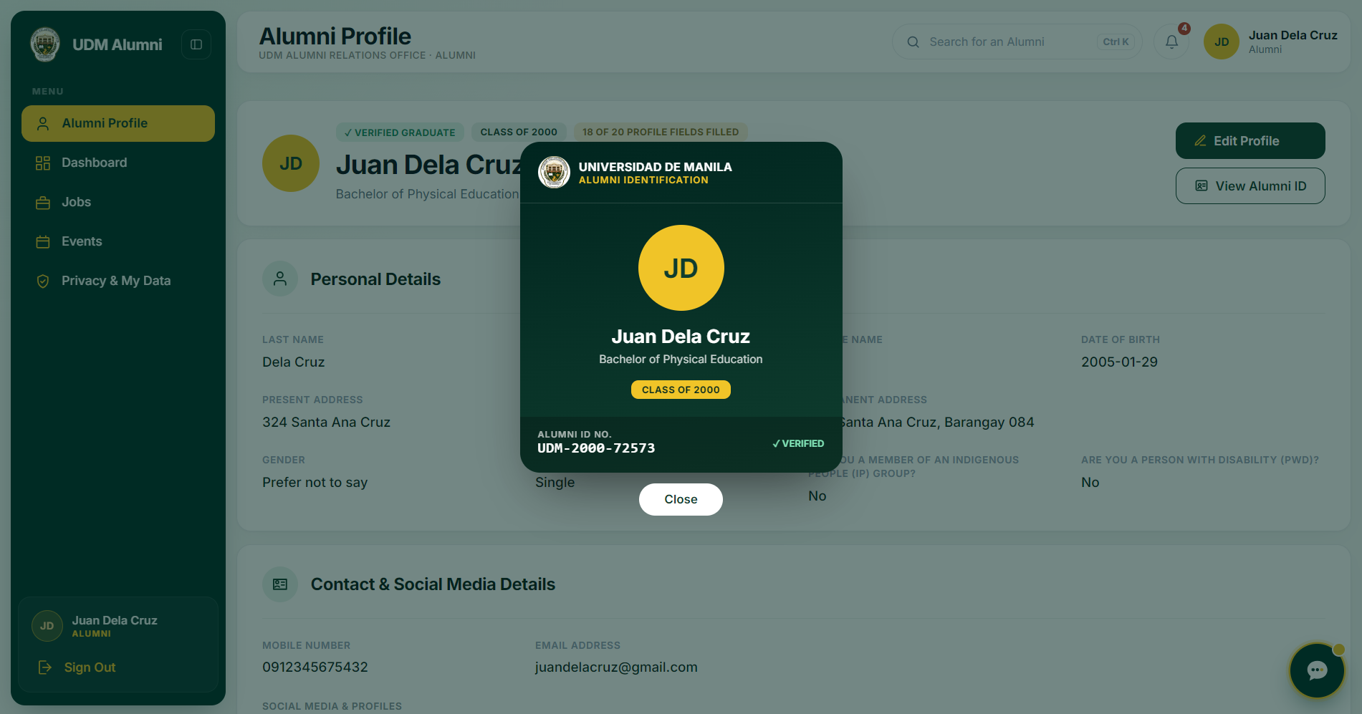
Figure 16. The digital Alumni ID card, displaying the user's verified status, name, degree, class year, and Alumni ID number.
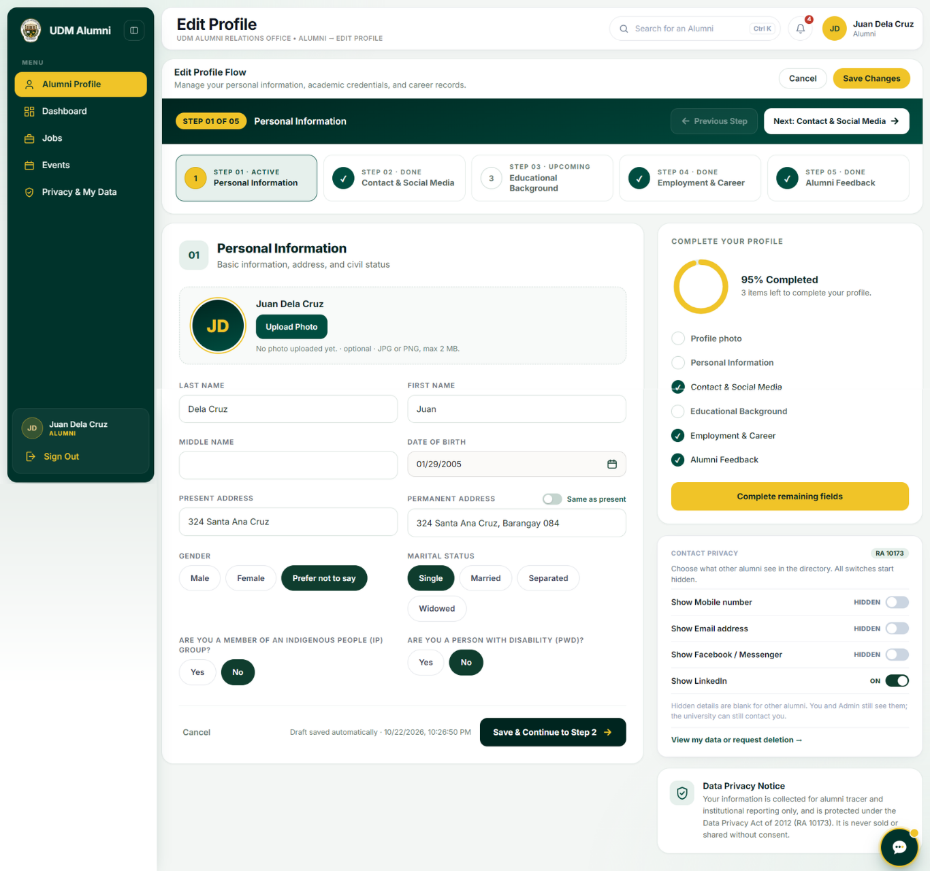
Figure 17. Edit Profile interface where alumni can review their profile completion progress across sections like education and employment, manage contact privacy settings under the Data Privacy Act of 2012, and provide feedback for the university before saving their changes.
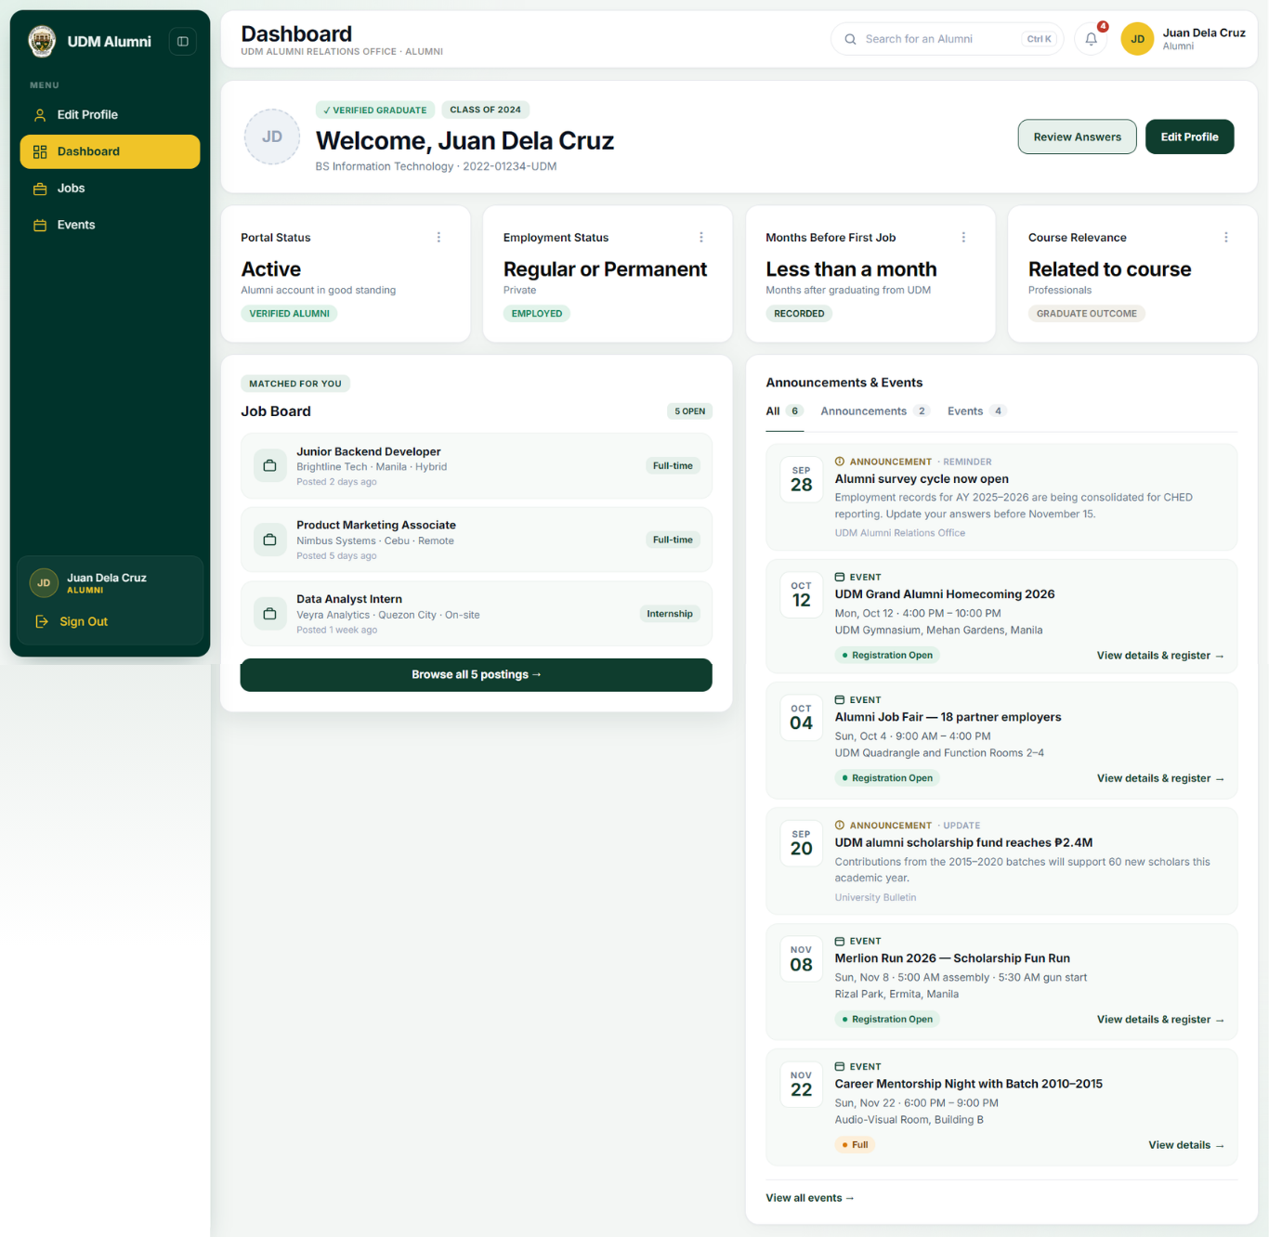
Figure 18. the Alumni Dashboard, which provides alumni with an overview of their profile, employment status, matched job opportunities on the Job Board, and a dedicated feed for university announcements and upcoming events.
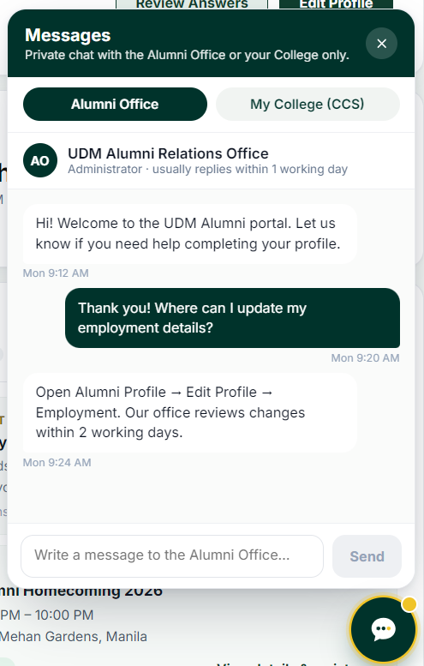
Figure 19. The private messaging interface, allowing alumni to chat directly with the Alumni Relations Office or their college department.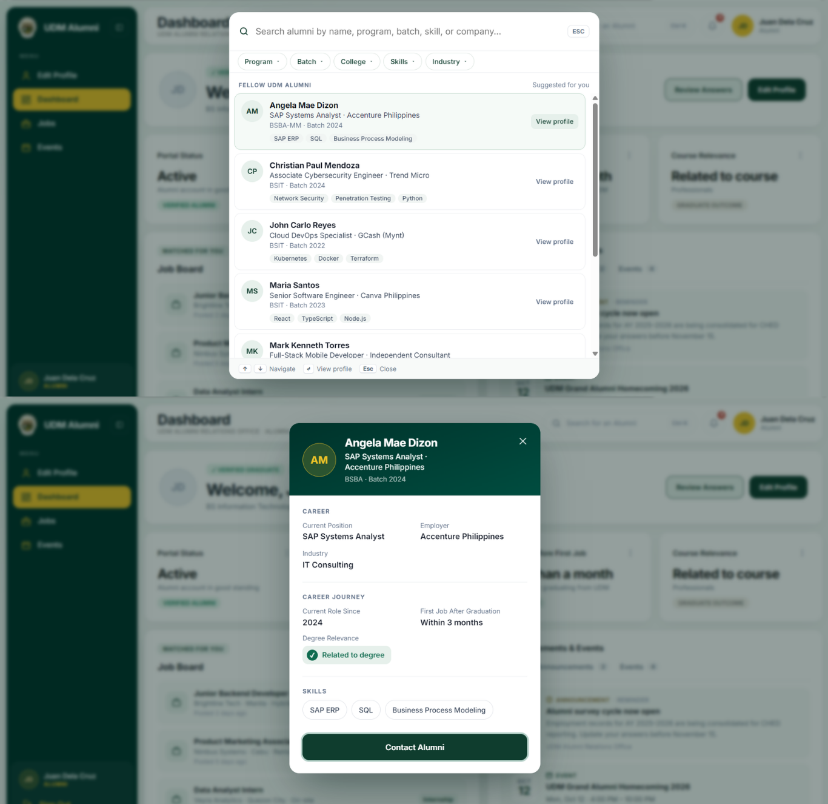
Figure 20. shows the alumni search feature with filtering options (top) and a detailed view of a selected alumnus's profile, including their career information and skills (bottom).
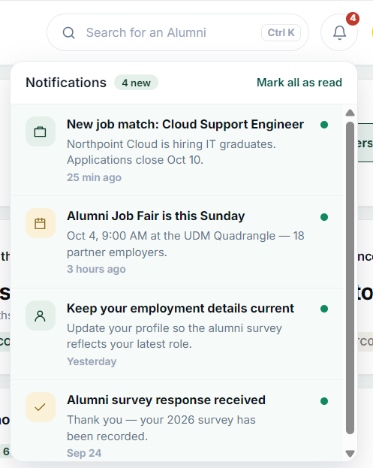
Figure 21. Displays the system's notifications panel, showing recent updates such as new job matches, upcoming alumni events, reminders to keep employment details current, and survey submission confirmations.

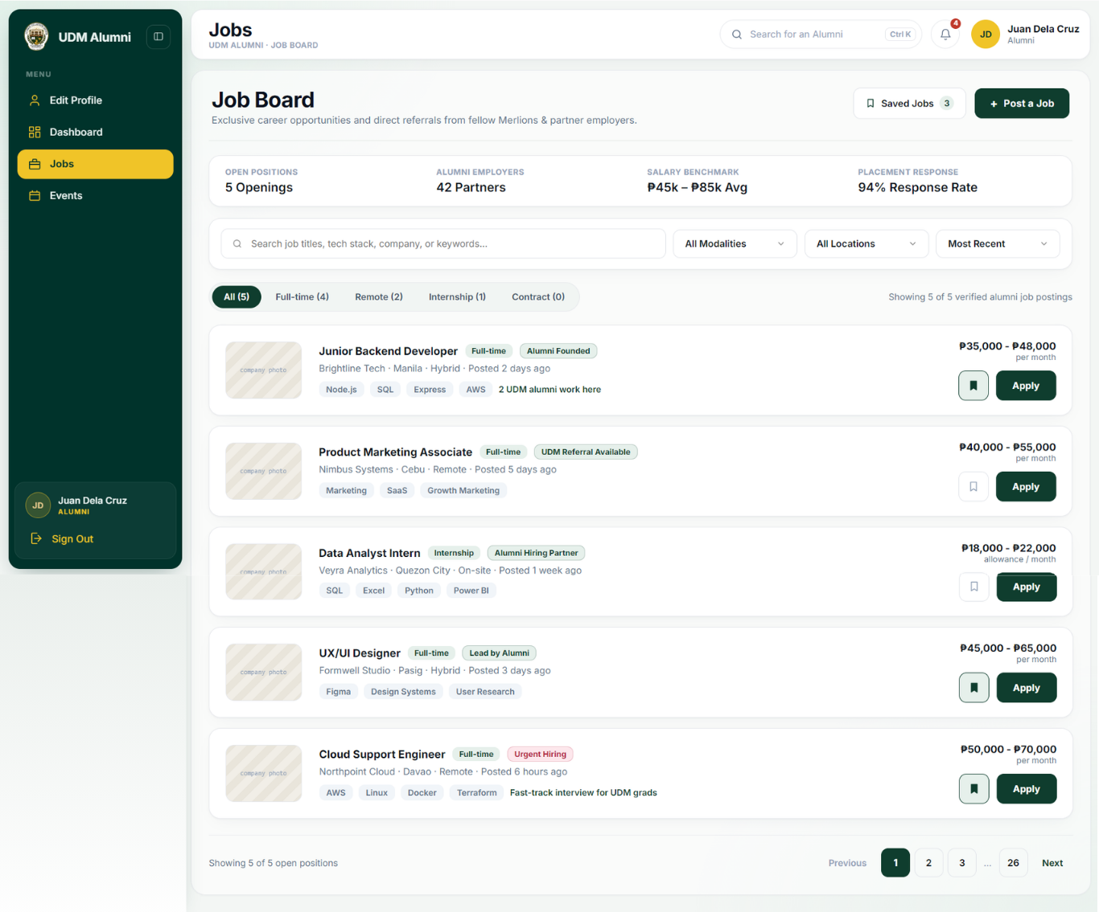
Figure 22. The system's Job Board interface, which allows alumni to browse open career opportunities and save it.
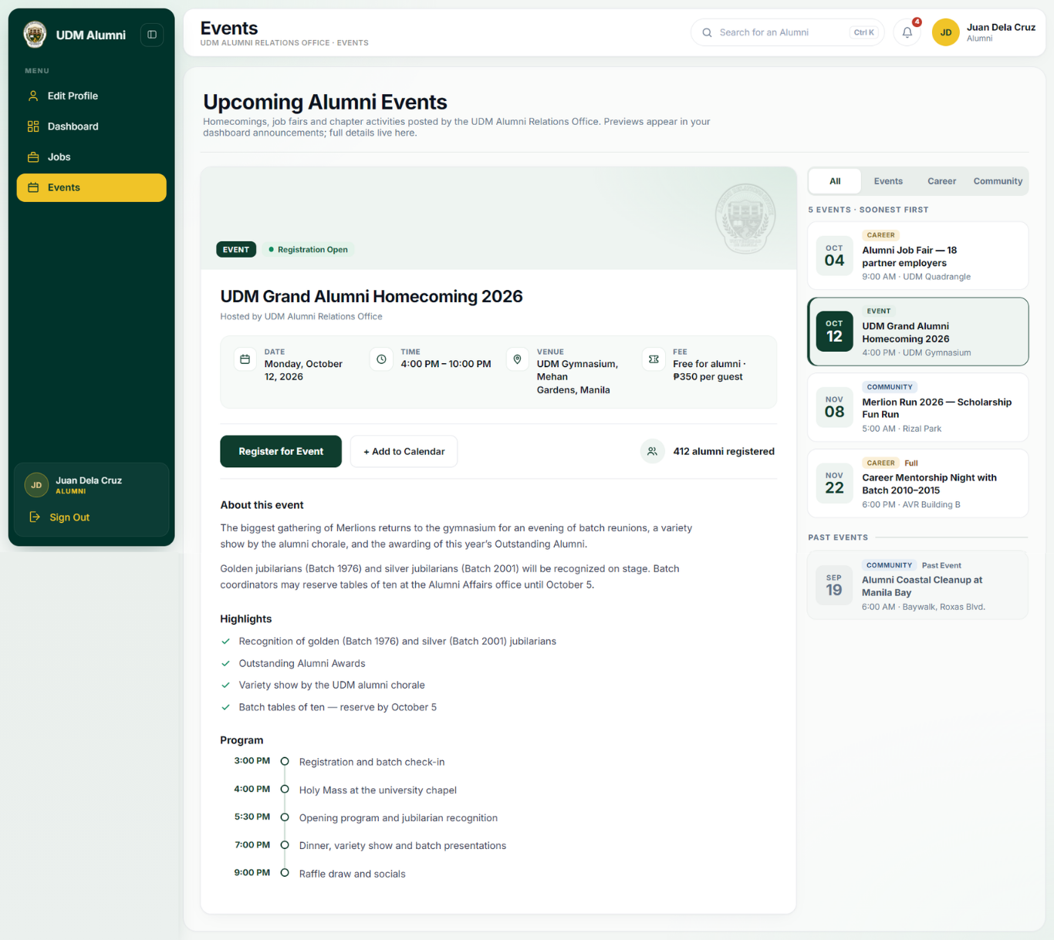
Figure 23. The Events interface, which displays details for upcoming alumni activities and a list of other upcoming or past events.
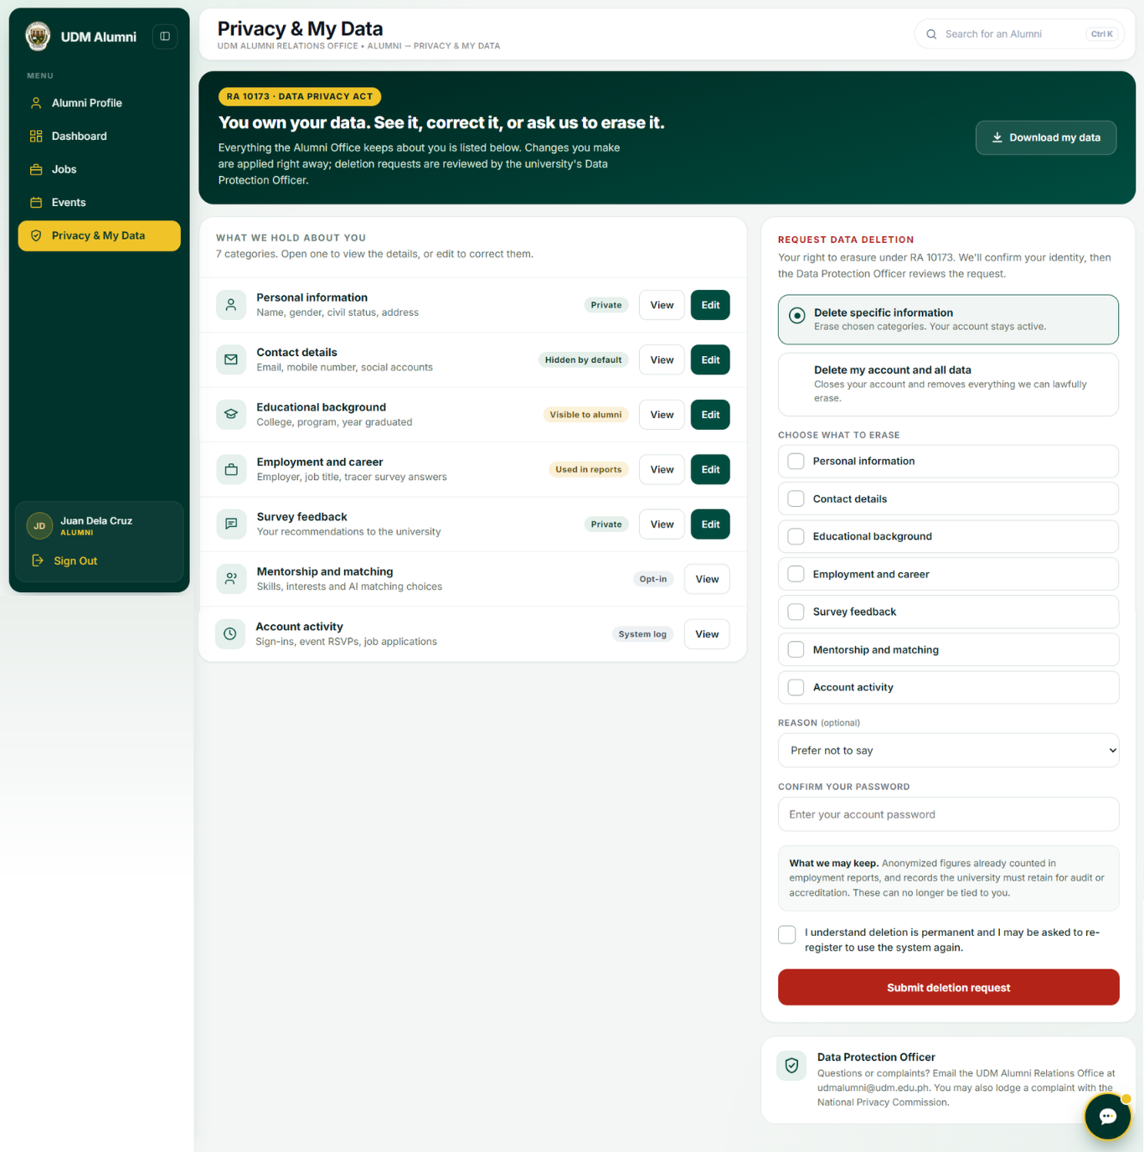
Figure 24. The Privacy & My Data interface of the UDM Alumni portal, which allows users to manage their personal information under the Data Privacy Act (RA 10173).
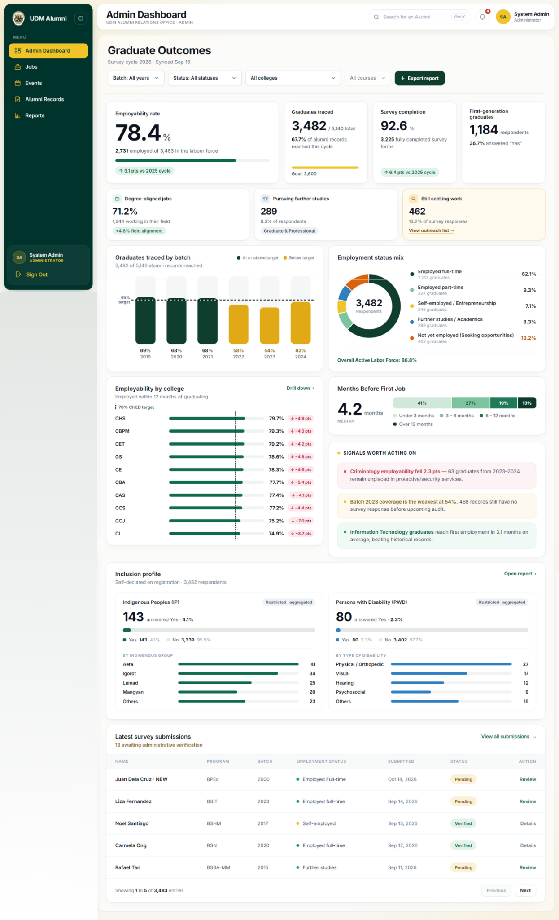
Figure 25. The Graduate Outcomes dashboard serves as the central analytics and monitoring interface for system administrators. It aggregates alumni tracer study data to track key performance indicators including overall employability rates, degree alignment, survey completion, and time-to-employment. Administrators can filter records by batch, status, college, or course, monitor institutional targets (such as CHED benchmarks and demographic inclusion profiles for IP and PWD graduates), view automated data alerts, and verify incoming alumni survey submissions directly from the submission queue.
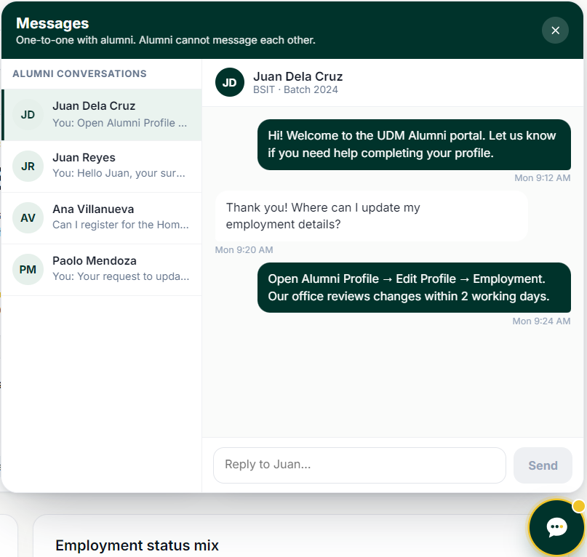
Figure 26.
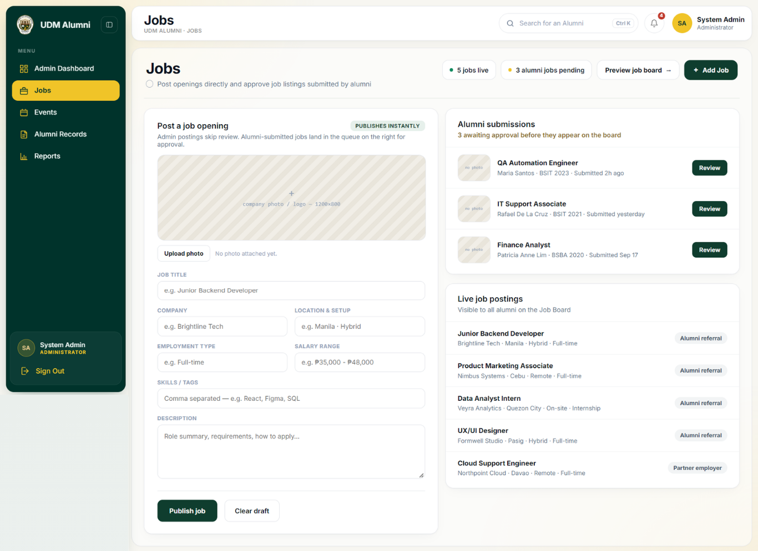
Figure 27. The Jobs Management interface in the UDM Alumni portal enables administrators to publish new job openings directly and moderate listings submitted by alumni.
Figure 28. The Events Management interface in the UDM Alumni portal allows administrators to create, track, and manage alumni events alongside official community announcements.
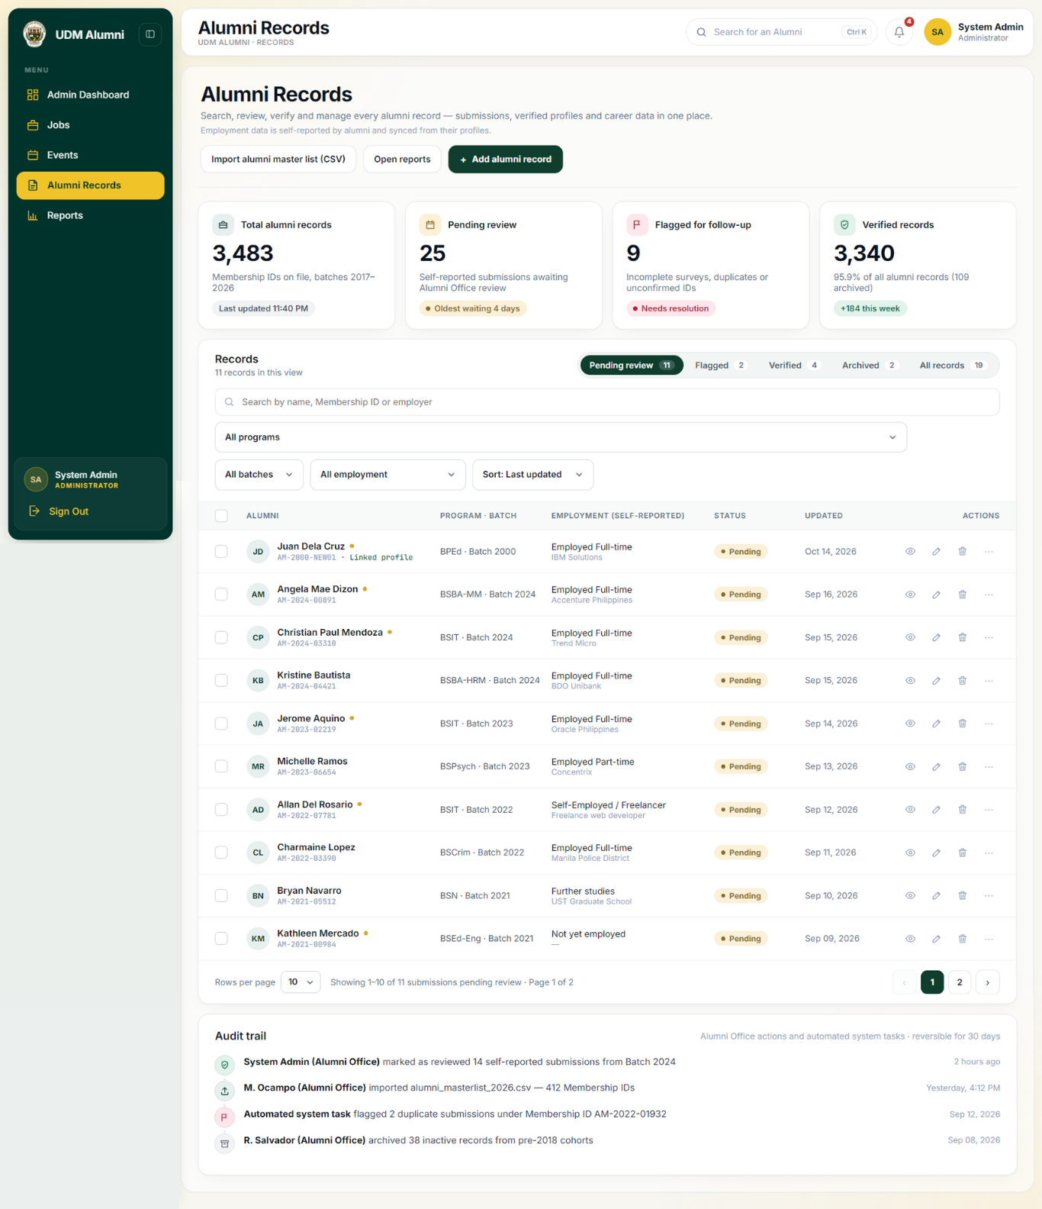
Figure 29. The Alumni Records Management interface in the UDM Alumni portal enables administrators to search, review, verify, and manage alumni profiles and self-reported career data.
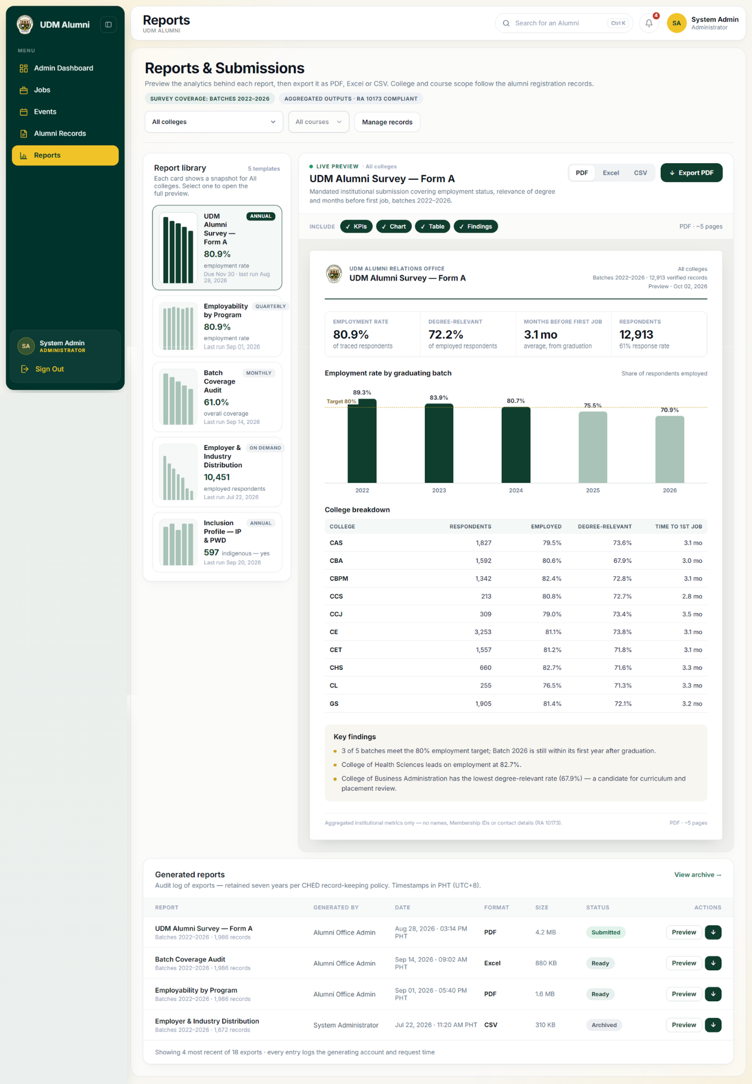
Figure 30. The Reports & Submissions interface in the UDM Alumni portal enables administrators to preview, configure, and export institutional analytics (such as employment rates, batch coverage, and industry distribution) in PDF, Excel, or CSV formats in compliance with RA 10172.
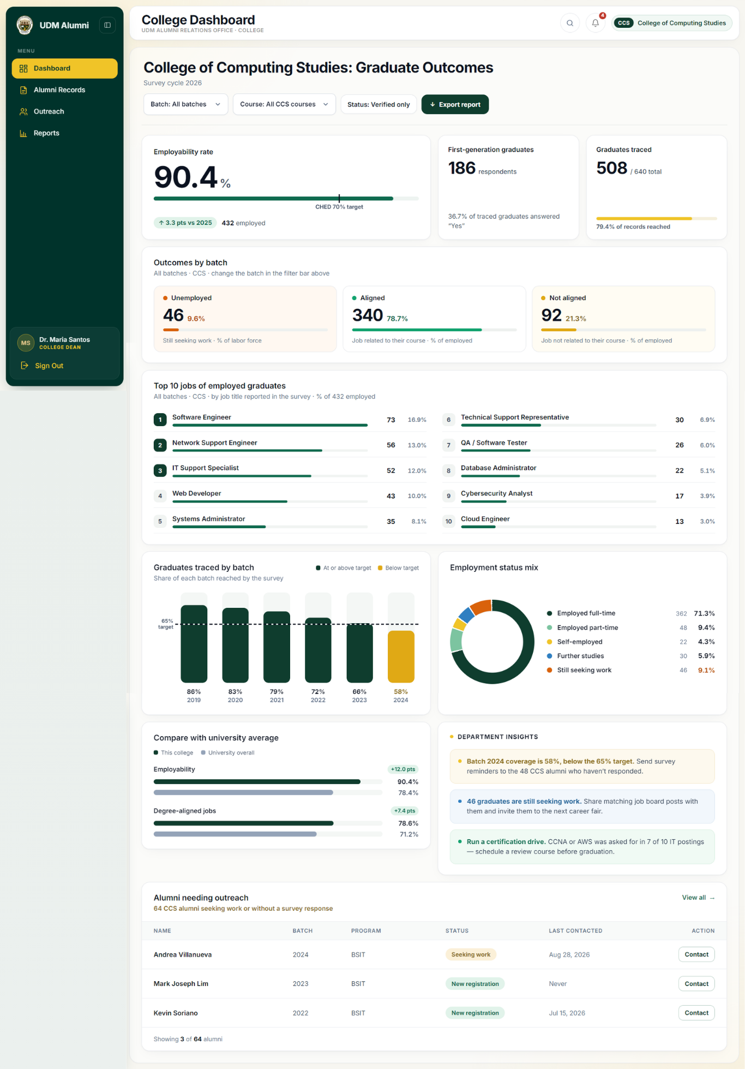
Figure 31. The College Dashboard (Graduate Outcomes) interface in the UDM Alumni portal provides college-level administrators (such as Dean and Program Head) with analytics on graduate employability, career alignment, and student outreach metrics for their specific academic unit.
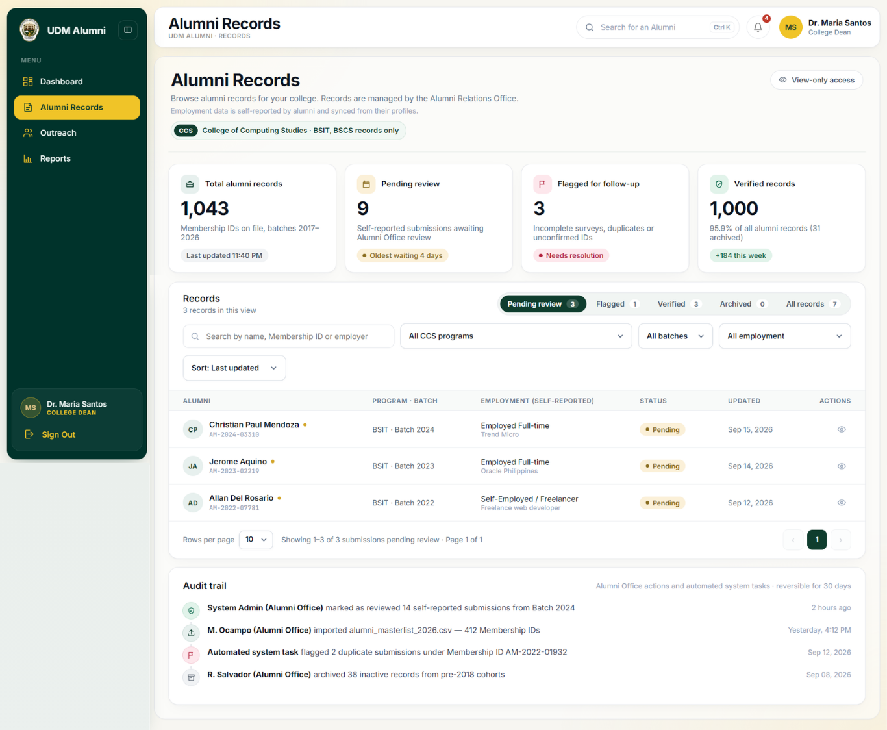
Figure 32. The Alumni Records (College Level) interface, read-only view to browse and monitor alumni data, verification progress, and employment updates for their specific academic unit.
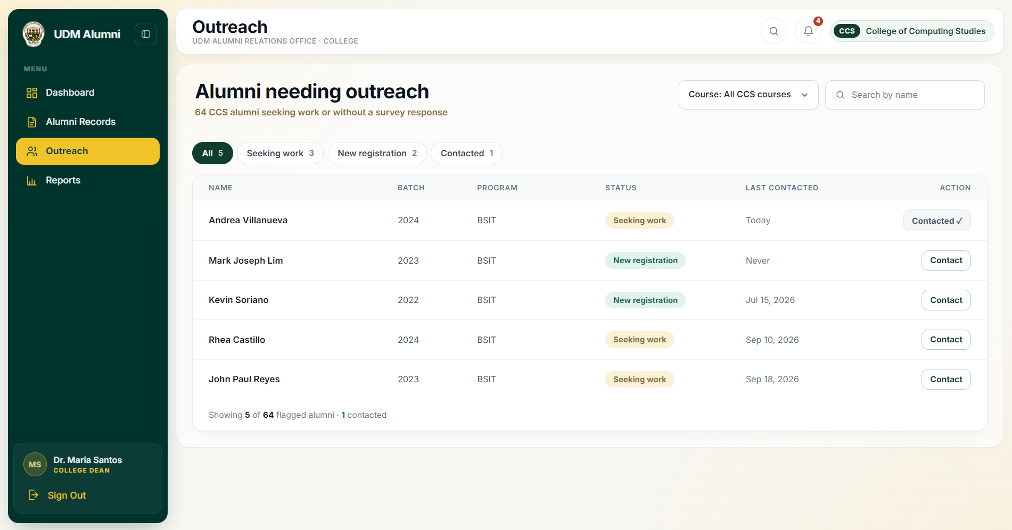
Figure . The Outreach interface in the UDM Alumni portal enables college administrators to identify, monitor, and initiate engagement with graduates who require career assistance or survey follow-ups.
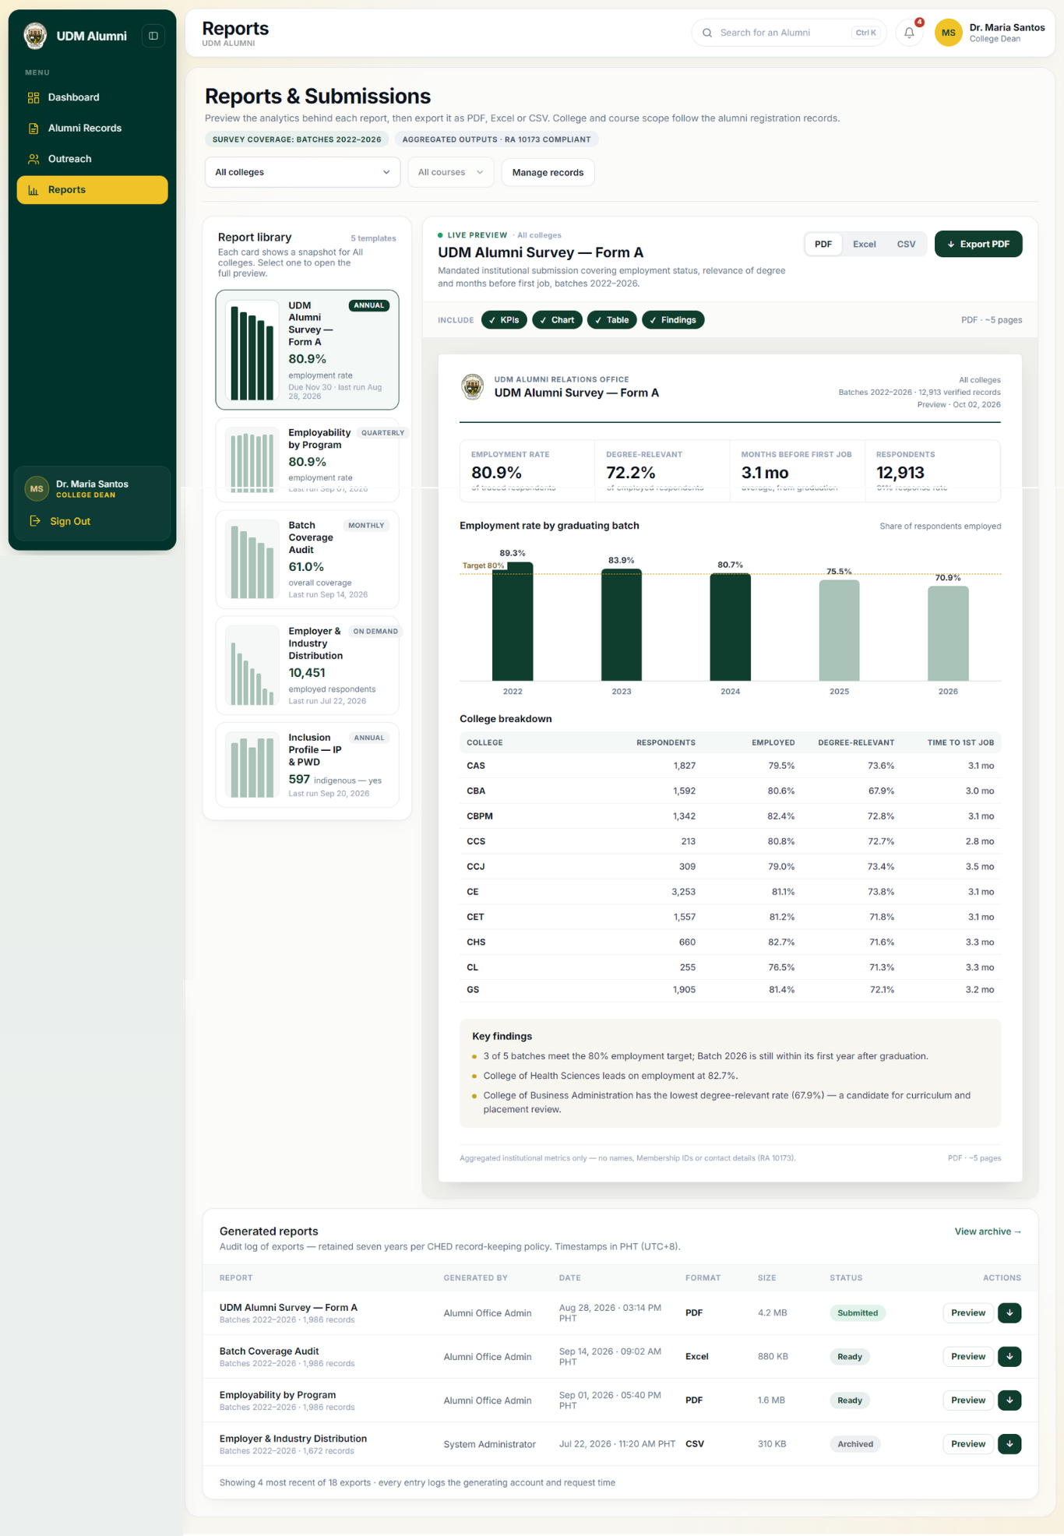
Figure 33. The Reports & Submissions in College Coordinator interface in the UDM Alumni portal enables college-level administrators to preview institutional and departmental tracer analytics, customize export layouts, and generate compliant reports in PDF, Excel, or CSV formats.

